FINAL PROJECT

CM 3070

FINAL REPORT

Table of Contents

Abstract 5
Chapter 1 6
Introduction 6
Chapter 2 8
Literature Review 8
2.1.0 Automated Essay Scoring (AES) Systems 9
2.1.1 Transformers 10
2.1.2 Optical Character Recognition (OCR) 11
2.1.3 Automated Speech Recognition (ASR), Speech-To-Text (STT) 13
2.1.4 Multimodal Systems 14
2.2.0 Challenges and consideration for component selection 17
Chapter 3 22
Design 22
Project Management 23
Design 25
Chapter 4 27
Implementation 27
Procedure 28
System Deployment/Implementation Details 29
CHAPTER 5 30
Evaluation 30
5.1 Test Environment 31
5.2 Unit Tests 32
5.3 Component Testing 36
5.4 Integration Testing 45
5.5 Functional System Testing 46
5.6 End-User Testing 48
5.7 Usability Testing 49
Chapter 6 50
Conclusion and Future Improvements 50
Future improvements: 51
Reference List 52
Appendix A - Consent Forms 56
The Prompt 78
Rubric Guidelines 78
Method for Feature Extraction and Accuracy Metrics 79
Unit Testing 83
Extracting and Displaying Reference Essay 84
Reference Essay Feature Extraction 85
Calculating Character and Word Error Rates 85
Normalized Reference Essay 86
Component Testing 87
Whisper (ASR) - Selecting the best model and configuration through experimentation 87
Display results for configurations 90
Display in ascending order of WER and CER accuracy 91
Whisper (ASR) Batch Transcription 91
Batch Transcriptions Technical Details 95
Descriptive Statistics 97
Threshold Performance 97
Representative Transcriptions 98
paddleOCR-OCR Model 101
Text Detection, Recognition and Extraction 102
Threshold Performance 105
Descriptive Statistics 106
Representative Extractions 107
Confidence Scores 110
Appendix C 112
Implementation/Installation Requirements 112

Abstract

Automated Essay Scoring is a rapidly developing research areas in NLP with respect to education. According to [1] this is due to the rapid progress in Artificial Intelligence which has created new possibilities. Some of the benefits of AES are enhanced fairness, consistency and efficiency in the scoring process [2]. This research has shown Optical Character Recognition (OCR) technology has the potential to provide accessibility to an AES system by allowing essays to be submitted in handwritten format as images. In limited experimentation with only two handwritten samples, PaddelOCR achieved average CER and WER scores of 0.771 and 0.962 respectively. This research investigates whether orchestrating OCR and ASR models along with a Transformer can produce an AES system this interpretable, accessible and reliable.
Add Whisper and later deBERTa performance
Double check these references, they may be out of order

Chapter 1

Introduction

The Proposed System
BrainPower- A hybrid, multi-modal, Automated Essay Scoring (AES) system which orchestrates an OCR, STT and Transformer model, providing accessibility for students and interpretability, readability and automation in support of human scorers.
The template selected
Template 4.1 Project Idea 1: Orchestrating AI models to achieve a goal
Rationale for topic selection
Reading and providing corrective feedback on a single 250-word essay can take 10-15 minutes on average and a typical English A class has 35 students. This manual approach does not scale well if a teacher is assigned to more than one class. As an educator, the author recognizes the stressful, time-consuming ordeal that educators endure when marking answers to open-ended questions, especially essay. Currently accessibility for students who can speak but are incapable of writing or typing due to disability is provided by means of a scribe. Although well intentioned, this arrangement demands extra human resources, is time consuming and can be intimidating to some students. It would be more beneficial to the student if they could submit an answer to a prompt independently by verbally expressing their ideas recording, transcribing and then having them evaluated. There should also be a mechanism in place to allow students who are unable to be present at school to be able to under supervision write essays and share photographs or scan copies of these essays.

Chapter 2

Literature Review

2.1.0 Automated Essay Scoring (AES) Systems
Key terms: traits, features, handmade features, engineered features, holistic score, neural networks, transformers, prompts, QWK - QWK (Quadratic weighted Kappa) evaluates the degree of agreement among human and AI scorers, it is a metric between 0 and 1, representing no agreement beyond chance and perfect agreement, respectively [1].
This section is designed to give the user a historical perspective on AES system describing their advantages and limitations and, in the process, justify the selection of PaddleOCR, Whisper and DeBERTa in the AES pipeline, to evaluate and score handwritten, typed and spoken essays.
What is AES?
According to [2], automated essay scoring refers to the process of grading student essays without human interference. An AES system takes as input an essay written for a given prompt (the topic) and then assigns a numeric score to the essay reflecting its quality, based on traits such as content, grammar and organization.
Early AES Systems-Handcrafted feature system
According to [3], early AES systems such as Project Essay Grader (PEG), IEA, E-rater, IntelliMetric and BETSY, all used handcrafted feature approaches. Handcrafted features are values that are encoded into feature vectors, for example, the first dimension of a vector may represent word count and the second, sentence length and so on. These are then fed to a neural network for processing. This approach gives features positional significance, resulting in an interpretable output.
According to [4], these features are meticulously designed by researchers based on linguistic expertise, allowing for adaptability to various scoring criteria. [4], although stating the fact that these systems were exceptionally accurate, noted that despite the reliance on handcrafted features, conventional AES systems demonstrate robust performance even with limited datasets.
Limitations:
[2] stated that the process of feature engineering is the most difficult part of building an AES system, and that it is also challenging for humans to consider all the factors that are involved in assigning a score to an essay. There is also no evidence to suggest that any of these earlier systems graded handwritten essays.
Feature engineered systems
Neural approaches engineer features like sentence length and number of paragraphs and encode these in dense numerical feature vectors. A dense vector can contain several numerical values relating to a feature or combination of features. These numbers have no positional significance to humans as compared to handcrafted features as they are assigned based on weight adjustments influenced by gradient descent. This enables the network to iteratively adjust weights to learn a model that can then generalise to score new essays.
[2] implemented a model for holistic scoring based on recurrent neural networks (LSTM), to learn the relationship between an input essay directly and its assigned score. The system encodes the information required for essay evaluation and learns the complex patterns in the data. Their system outperformed a strong baseline by 5.6% in terms of QWK, without requiring any feature engineering.
Limitations: The system was not tested on a handwritten dataset, especially not one with cursive handwritten essays. According to [5], neural approaches provide scores without giving evidence of how they are arrived at. Since one of the goals of BrainPower is to produce interpretable results, a neural approach will not be employed.
Furthermore, more modern approaches such as transformers have been shown to be superior to neural approaches. [6] compared the performance of three neural approaches LSTM, Bi-LSTM and BERT a transformer model and concluded that the transformer model offered superior performance. [5] reviewed several pretrained models in AES and discovered that BERT outperformed all of them achieving a QWK of 0.83.
2.1.1 Transformers
Transformer models work by using an attention mechanism that relates each token in the text to every other token thus enabling them to capture long-range contextual dependencies. According to [3], they make use of huge datasets of existing general text data, such as Wikipedia Corpus, to pretrain multilayer neural networks with context-sensitive meaning of and relationships between words.
[4] compared the performance of several models on an AES task. The results show transformer models outperforming traditional models, achieving higher QWK scores. The best performer was a NCPR model, which used contrastive learning and utilised BERT for feature extraction achieved a QWK of 0.817, indicating a close similarity to human scoring.
[3] suggests not relying solely on transformer models and like [4], proposed a technique of combining transformers with more traditional approaches like those that employ handcrafted features. [1] argued that human evaluation remains important since expert markers can identify subtle linguistic and cognitive qualities that automated systems may overlook. [4] indicated that when models work in combination the results are more promising. [7] used a hybrid model – LSTM and Word Embedding and achieved a QWK of 0.94. [3], [4] and [1] all give compelling reasons for a hybrid design for an AES system but do not give explicit indication of the format that the essay must be in for evaluation.
Limitations: As effective as stand-alone neural approaches are, they are usually criticized for their lack of readability and interpretability by humans, as was mentioned in [5]. Several studies cited in [4] have shown that to be effective at AES tasks, transformer models require fine tuning.

2.1.2 Optical Character Recognition (OCR)
[8] defines OCR as a computational technology that extracts text in an editable format from PDF files, scanned or hand-written documents, images etc. [9] describes traditional OCR systems as comprising two modules: a text detection module and a text recognition module. Text detection localizes all text blocks at word-level or text-line level while text recognition aims to understand the text image content and transcribe the visual signals into natural language tokens [9].
Mostafa et al. [10] summarized work done using OCR to digitize Bangla scripts - a diverse and complicated language in written form. They concluded that CNN architectures are the most accurate tried and tested method for that task. Although no evidence is given of the performance of transformer models, the researchers do acknowledge their potential. The decision to experiment with Bangla script as compared to English may be due to its perceived difficulty compared to English although the research did not make that claim.
Limitations: No mention is made of other architectures or listing of benchmarks for a performance comparison. Also, the study does not give evidence of CNNs being trained on English language typed or cursive handwriting datasets.
Tr-OCR
[9] achieved state-of-the-art results on printed, handwritten and scene text image datasets with Tr-OCR, an end-to-end Transformer-based model. Tr-OCR achieved word-level precision, recall and F1 scores of 96.59, 96.57 and 96.58 respectively on the SROIE (Scanned Receipts OCR and Image Formation Extraction) dataset. It also achieved a state-of-the-art CER (Character Error Rate) of 2.89 on the IAM Handwriting Dataset, a dataset containing, according to [11], natural variety, cursive elements and mixed script samples of handwriting.
Limitations: According to [12], Tr-OCR is designed for single-line text detection and failed to extract text from full-page or paragraph-level images. In one experiment it achieved a low accuracy of around 50-60% in text extraction.
BrainPower relies on full page text extraction so to utilise Tr-OCR essays must be segmented into a series of sentence-images, fed to the model and then recombined. This begs the question; can the OCR function of BrainPower utilise Tr-OCR's proven handwriting recognition and PaddleOCR's robust text detection capabilities?
A study carried out by [13], where YOLOv10, an object detector, was integrated with Tr-OCR and PaddleOCR for reliable text detection, found that Tr-OCR provided the best overall solution for reliable, high-accuracy container ISO code recognition with a recognition accuracy of 92% outperforming PaddleOCR, a hybrid CNN-Transformer model.
Limitations: The research was carried out on text printed/painted on containers. Such text is usually printed using a stencil ensuring uniform height and spacing. There is also no evidence from this research to support the usage of YOLO and PaddleOCR in combination for detecting handwritten text.
PaddleOCR
[14] PaddleOCR is an open-source OCR model launched by Baidu Paddle. The architecture always maintains the three-stage pipeline design of "text-detection + direction classification + text recognition". [14] tested the model on a dataset containing 200 national grids stand slogans and power supply line maps collected on the spot at a power generation environment. The images were captured at different angles under varying lighting conditions. The model achieved high detection accuracy of over 95% for standardized slogans and power supply circuit diagrams. It also achieved 93.3% and 86.6% average recognition for standardized slogans and power supply circuit diagrams respectively [14].
Limitation: This study focused solely on block printed text, which is generally uniform, evenly spaced and aligned. As such there is no evidence to suggest that PaddleOCR can recognize handwritten text. However, it recognizes text from whole page documents, unlike Tr-OCR. These studies focused on OCR, but ASR presents an optional modality for presenting an essay for evaluation.

2.1.3 Automated Speech Recognition (ASR), Speech-To-Text (STT)
[15] A speech-to-text (STT) system accepts an audio input signal from either a person or a machine and detects and converts individual words and phrases into text. [16] Advances in deep learning technology has profoundly transformed automatic speech recognition (ASR) over the past decade. Historically, ASR systems were constructed from a complex pipeline of independently trained components for example, a pronunciation model (lexicon) and a language model (LM). Like early AES systems, features had to be hand engineered, which was tedious and did not scale well.
[17] described how three major research groups - Microsoft Research (MSR), Google and IBM Research, achieved significant improvements in a variety of state-of-the-art ASR systems with Deep Neural Networks. According to [16], the modern era of ASR is defined by firstly, a shift towards end-to-end (E2E) models – systems that learn a direct mapping from acoustic features to text using a single, jointly optimized neural network which simplifies training and improves performance. Secondly, a shift in the data paradigm. Early deep learning systems used supervised learning to train on large datasets of labelled data. Modern systems have moved towards unlabelled data. Self-supervised systems have demonstrated the ability to learn from raw audio data while weakly supervised systems have demonstrated the ability to generalise to data they were never trained on [16].
Whisper
[18] One model that exemplifies this shift is OpenAI's Whisper, a transformer. [19] For translation tasks, the Transformer can be trained significantly faster than architectures based on recurrent or convolutional layers. The Whisper model was trained on an enormous dataset of 680,000 hours of labelled audio. Whisper transcribed 950 out of 1000 words correctly in research carried out by [20] achieving 95% accuracy. The model's integration into classroom technology effectively supports students with diverse linguistic, cultural, and ability-based needs, achieving high accuracy and frequency responsiveness. Whisper is a valuable tool for educators seeking to foster a more accessible learning environment [20].
Limitations: Occasionally Whisper hallucinates. [20] discovered that about 1% of transcriptions contain fabricated phrases that were not present in the original audio, and that a significant portion of these can lead to harmful implications. The study further indicated that systems which lack the necessary processing power will experience transcription latency, as Whisper models occupy gigabytes of storage space and this may be undesirable.

2.1.4 Multimodal Systems
This section discusses some multimodal systems that share some similarity with BrainPower but however, fail to provide in entirety for all input modalities, catering to students who have writing disabilities. These observations present the following two gaps that this research hopes to fill:
Gap 1 - most AES systems ignore input equity.
Gap 2 – the architecture of commercial multimodal products is not accessible for analysis.
An extensive search of Google Scholar, IEEE Explore, ACM and similar services and querying current AI applications like ChatGPT and Gemini with the search terms "multimodal AES", "accessible multimodal AES" and "hybrid multimodal AES" reveals that such systems are exceptionally rare. The results returned were of systems that orchestrated at most two AI models of disparate modality. This indicates a gap in current AES technology revealing that most AES systems ignore input equity.
The architecture of commercially available multimodal systems such as IntelliMetric® are not freely available for analysis. My research project intends to fill the gap by implementing an accessible, interpretable, hybrid, multimodal AES system by orchestrating three pre-trained models – an OCR, ASR and a transformer model that accepts as input, written, typed and spoken essays and transparently scores them.
CAFES
[21] proposed a multimodal AES system called CAFES that uses a MLLM to process graphics e.g. a scenery along with text. The system orchestrates GPT-4o as the MLLM. The dataset used for their experiment is the ESSAYJUDGE dataset which consists of 1,054 multimodal essays written at the university level. This dataset is limited in that it does not cover complex visual inputs such as film frames.
Limitation(s): This system although multimodal, is still not designed to cater to students with disabilities, as it, like other AES systems ignores input equity.
ExaGrade
[22] developed a multimodal system ExaGrade that integrates optical character recognition (OCR) with the generative pre-trained transformer (GPT). The platform integrates two pre-trained models - HandwritingOCR to extract text from handwritten exam papers and like [21] employs GPT-4 to evaluate and score student responses. The platform offers features such as exam creation where for MCQs and TFs the teacher supplies the answers, and student exam completion using handwritten or online modalities.
Limitation(s): The platform is described as accessible; however, accessibility only encompasses availability online at GitHub since the platform is released as an open-source project [22]. ExaGrade is not accessible to students with writing disabilities. Notably absent from the system is a means to input an essay in audible form.
[23] proposed VisualAES, a bi-modal system that utilizes both textual and visual features for handwritten essay scoring. It orchestrates three pretrained transformer-based models to take both textual features and visual features extracted by Faster R-CNN and then uses a stacking ensemble model to robustly map their output to a final score. This system's architecture is more congruent with what is being proposed in this research – an OCR model to convert text from scanned essays to digital text for processing, and a transformer model for essay scoring. VisualAES was evaluated on the Automated Student Assessment Prize (ASAP) dataset and their own handwritten Chinese Student's handwritten essay dataset (ChnStd). Their results showed that their system outperformed all state-of-the-art methods on both datasets.
Limitation(s): VisualAES like CAFES does not provide accessibility for students suffering writing disability.
[20] developed an inclusive learning classroom using the OpenAI Whisper model. The model was selected to promote diversity and inclusivity in education through real-time transcription and translation for students with diverse linguistic and cultural abilities and backgrounds. The results were encouraging as the model achieved high accuracy especially in an environment where ambient noise did not alter the audio signal input. This system however is limited in input modality as it only focuses on audio transcription with no allocation made for submission of handwritten work.
[24] developed a system for investigating the possibility of automatically grading handwritten essays by leveraging OCR together with a fine-tuned and trained Large Language Model (LLM) Mistral 7b. According to the BERT Score analysis, the precision, recall and F1 scores were observed to be consistent over all the essays. The F1 score of 85.78% demonstrates the model's overall stability in replicating human-grading decisions with a high degree of consistency. The system used a Moodle plugin that integrated Mistral 7b into the platform.
Limitation(s): There is no mention of inclusivity in the system developed by [24] showing once again that most modern AES systems focus on the quality of essay scoring and do not prioritize input equity, emphasizing the need for an integrated system.

2.2.0 Challenges and consideration for component selection
The datasets
According to [3], the most elaborate AES systems currently have trouble accurately evaluating the coherence and persuasiveness of an essay, or an argument's clarity, and that is due to two main reasons: (1) such aspects are very hard to model, and (2) the lack of datasets that provide human-graded dimension-specific data, especially compared to those that provide holistic scoring. [5] indicates that the problem originates from AES research relying heavily on the ASAP dataset as the primary benchmark, highlighting the limited options available. Additionally, most publicly available datasets are tailored toward English-language assessment e.g., TOEFL11, CELA, or the Cambridge English assessment datasets.
[21] further emphasizes this limitation, describing the ASAP and its extended version, ASAP++, as both containing few topics. ASAP++ adds trait-level annotations but merges key content traits into a single "CONTENT" label, decreasing granularity and interpretability. The TOEFL11 dataset, similarly, uses only coarse-grained proficiency labels (low / medium / high). Thus, models trained on the TOEFL11 dataset will inherently produce results that are difficult to interpret due to the granularity of the training data [21].
[5] also points out that the dataset availability and diversity issue is not limited to the field of research, but extends to commercial products, which primarily focus on English-language datasets. The quality, quantity, and availability of the data are fundamental to the model's performance. It is fitting to consider available models, discuss the impact the limited datasets have on them and propose the best option to provide reliable, interpretable trait scoring.

The models
[5] presents some of the issues with Transformer pretrained models as having a closed-box nature, high computational requirements, longer training times and the need for large datasets. Additionally, issues presented by [5] are data quality, biases in training data, generalization, and overfitting which still pose significant obstacles that need to be addressed.
[22] cited three studies that showed the limitations of ChatGPT, a transformer model, as an AES tool. The results indicated that ChatGPT often scores lower than human scorers and its evaluation is inconsistent due to variations in its scoring mechanism, training data, model updates, and ingrained randomness. [22] Additionally, the consistency of ChatGPT's scores over multiple evaluations was low, indicating variability and raising concerns about its reliability.
[25] explored the potential of using GPT-based models as an alternative solution to the data scarcity issue, comparing their performance to that of fine-tuning BERT models, which remains the state-of-the-art, in quantitative text analysis. They concluded that BERT models remain the overall go-to method for classification although GPT models can serve as alternatives on smaller tasks. GPT models are also easier to tweak; however, they are more expensive. Due to the findings of [22] and [25], GPT will not be included in this system.
[26] DeBERTa (Decoding-enhanced BERT with Disentangled Attention) is an improvement of previous state-of-the-art pre-trained transformer models such as BERT and RoBERTa, its predecessors. [26] BERT and RoBERTa represent each word in the input layer by a single vector which is the sum of its word (content) embedding and position embedding. Each word in DeBERTa, however, represents a word with two vectors that encode its content and position, respectively, and the attention weights among words are computed using disentangled matrices based on their contents and relative positions [26].
[26] DeBERTa, after training on 78GB of data, outperformed RoBERTa, which was trained on 160GB of data and surpassed human scoring on the SuperGLUE benchmarks for the first time since 2021. This benchmark includes a wide range of tasks such as question answering, natural language inference, and word sense disambiguation [26].
DeBERTa has been selected to form the core component in the essay processing pipeline for BrainPower, serving as the final step before the end user receives a breakdown of how the traits are scored. This decision is based on the empirical research that showed it outperforming human scorers and other state-of-the-art models on established benchmarks, making it more suitable for the AES task. DeBERTa is also freely available from the Hugging Face platform and offered under the MIT licence, facilitating freedom of modification and reproducibility.

Limitations of OCR in general
The accuracy of OCR models in recognizing text from images depends on the quality of its input image. High-quality images have clear, uncluttered text, no background noise (such as smudges) and are captured in well-lit environments. Most classroom environments, however, do not provide all these conditions. Furthermore, quality of images is determined by the photographer's ability to hold the camera steady and the quality of the camera used to capture the image. Consequently, selection of an appropriate model is critical to preventing errors from propagating through the pipeline as errors fed into the core (DeBERTa) will degrade its scoring accuracy.
Several popular models struggle to decipher handwritten text or are only capable of extracting text from one language. Others are limited to handling only single lines of text and cannot scan whole documents, making it necessary for a text extraction add-on. One such example is Tr-OCR, according to [12], which is designed for single-line text detection and failed to extract text from full-page or paragraph-level images, in one experiment achieving a low accuracy of around 50-60% in text extraction [12].
It is for these reasons, along with the findings of [14] discussed previously, that PaddleOCR has been selected as the OCR input component for BrainPower. Since it is beyond the scope of this research to fine-tune a model, the capabilities of PaddleOCR make it an ideal candidate for inclusion in BrainPower's AES pipeline.

Limitations of ASR (STT) in general
[27] noise interference, echoes, accents, dialect variation and overlapping speech have a degrading effect on the performance of speech-to-text (STT) and text-to-speech (TTS) systems, resulting in transcription errors. As with OCR systems, ASR systems are vulnerable to environmental conditions as these determine the quality of the input, which invariably determines the quality of the output. According to [27], model and dataset scarcity are the reasons why the issues mentioned earlier still pose a challenge to modern ASR systems.
This issue of dataset scarcity seems to be a common thread among modern AI models, since they rely heavily on data for training and testing, underscoring the need for greater diversity and availability. These limitations are taken into consideration however, and Whisper will serve as the ASR/STT component of BrainPower due to its accessibility and state-of-the-art performance. The results from both component and integration testing will indicate if the model needs to be fine-tuned or replaced.

Limitations of Multimodal Integrated Systems
Multimodal integrated systems inherently suffer the same issues as their constituent components – OCR, ASR, and Transformer models. Additionally, they face issues such as:
- Computational complexity: orchestrating three pretrained models requires a lot of processing power and storage space.
- Error propagation: It is likely that mistakes from either the audio transcription done by the ASR or from recognition and digitization by the OCR will flow as input to the AES system core. If errors in the input data are not detected and handled correctly, they will propagate and reduce the core component's accuracy and reliability, resulting in inaccurate essay scores.
- Modality imbalance: Typed essays may score higher than handwritten or audio-transcribed essays due to noise introduced by OCR or the accent or dialect of the speaker for example.
- Data Bias: The pre-trained models are inherently biased towards the data they were trained on.
It is therefore incumbent on the designer to mitigate error propagation by detecting errors in the output from the ASR and OCR using metrics such as WER and CER and managing them at the component level, alerting human scorers when review is necessary.

Chapter 3

Design

Design

The diagram below shows a high-level design of the BrainPower system. The system will contain three (3) core components – two (2) input components, ASR and OCR. The ASR model, (OpenAi Whisper) will transcript spoken essays to digital text. The OCR model, (Paddle-OCR), which detects and recognises text in a JPEG image and records this as digital text. The core of the system is the transformer (DeBERTa) that accepts input essays in digital text format from the other two components and scores the input essay according to a rubric.
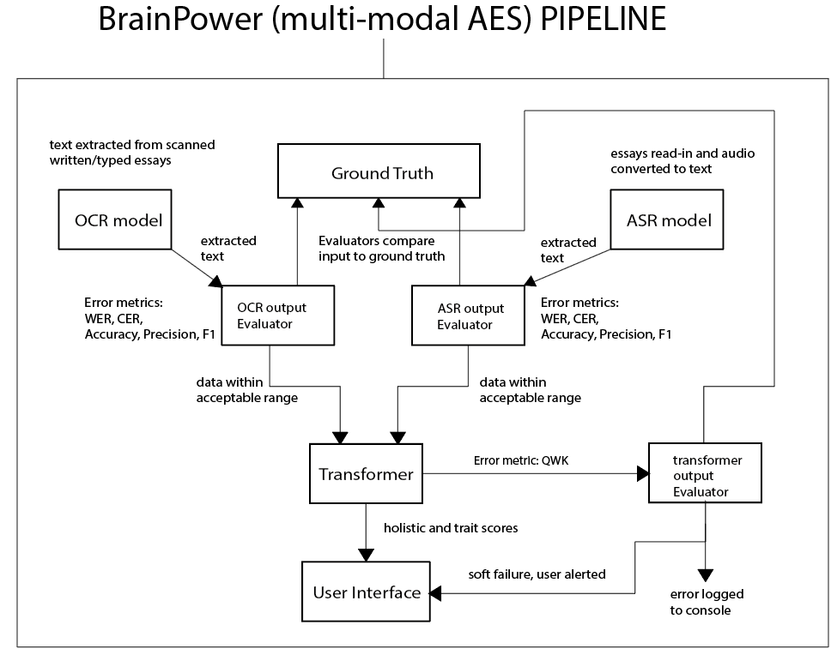
Figure 1 Architecture of BrainPower
The system will use the OCR and ASR evaluation logic to filter essays based on the WER and CER forwarding them to the transformer if they are within the acceptable threshold and to the human scorer is they are not.

Typical Workflow:
Scenario 1:
- Input (image of handwritten or typed essay) submitted to the OCR model
  - Model extracts text from the image and outputs digital text to its Evaluator
  - OCR Evaluator runs metrics such as WER, CER etc. referencing ground truth
    - Results within acceptable range: text forwarded to transformer for evaluation
    - Unacceptable results: system displays message to user, fails softly, logs details
Scenario 2:
- Input (read-in essay) submitted to the AST/STT model
  - Model extracts text from the audio and outputs digital text to its Evaluator
  - ASR Evaluator runs metrics such as WER, CER etc. referencing ground truth
    - Results within acceptable range: text forwarded to transformer for evaluation
    - Unacceptable results: system displays message to user, fails softly, logs details
Scenario 3:
- Input (essay in text format) submitted to the Transformer model
  - Model processes text and logs results to its Evaluator
  - Transformer Evaluation runs metrics such as QWK referencing ground truth
    - Results within acceptable range: text displayed to human scorer
    - Unacceptable results: system displays message to user, fails softly, logs details

User Interface
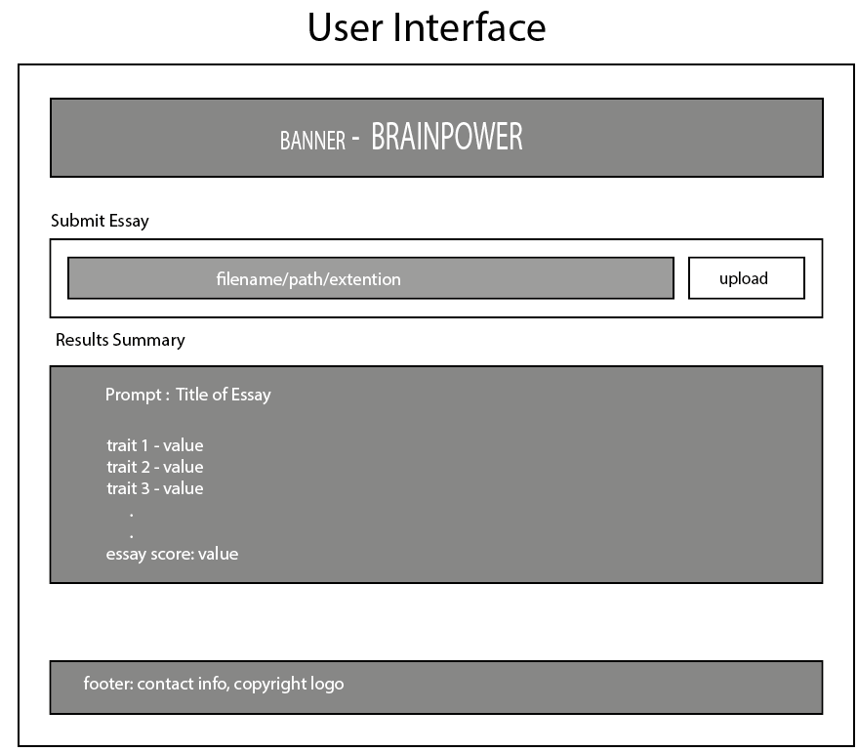
Figure 2 User interface for BrainPower system
User-interface components:
- Banner: this section displays the name of the application and may contain links or a form for user login
- Submit Essay(s): this section is designed to allow the user to upload the essay in disparate formats e.g. pdf, wav, or jpeg, for evaluation. The user will click on the upload-button, and a window will display to allot them to choose a file(s) for scoring. This section supports diversity as essays can be uploaded as both image, document and audio files.
- Results: this section will display the output after the transformer model processes and scores the input file. The textual display will comprise of traits and their respective trait scores and a final holistic score. This is to satisfy the readability and interpretability requirements of the system.
- Footer: this section will contain copyright data as well as links to sections for correspondence such as contact us form/page. This section does not contribute to the pipeline however it does contribute to the overall aesthetic of the system and follows the conventional web interface design paradigm.
Models
deberta-v3-base
PP- OCRv6
whisper-base.en
In-scope
- User Interface – Webpage, Django Web Framework
- OCR model – PaddleOCR - PP-OCRv6_medium_det
  - English Language only
- STT/ASR model – OpenAI - whisper-large-v3
  - English language only
- Transformer model – Microsoft – deberta-v3-base
  - English language output only
- Local execution
- Back end – Sqlite3
Out of scope
- Multi-lingual input/output, limited to English
- Multiple choice exams evaluation
- Long answer questions evaluation
- Reading comprehension exercise evaluation
- (scene text) Essays with visual prompts/visual content such a scene along with a prompt requiring students to write about the scene.
Text-to-audio conversion

Chapter 4

Implementation

Code Design

Model Specification (loading etc)
Get_files_metadata function
The EssayEditor Class
Calculate_error_rates function
BatchDataOperator Class

Procedure
To evaluate the performance of the system the following approach will be used:
Data input to OCR – WER and CER metrics will be calculated and used to determine whether the output should be sent to the core for further processing or a flag raised for human scorer intervention
Data input to ASR- WER and CER metrics will be calculated and used to determine whether the output should be sent to the core for further processing or a flag raised for human scorer intervention
Data input to AES – will output trait scores along with a QWK which will be used to describe proximity of the system’s scores to that of human scorers along
Datasets –this research will use the ASAP 1.0 dataset for training and testing BrainPower
Testing Plan
About 25-30 students will be selected to form the sample. Each student will produce one handwritten essay, after which they will snap a photograph with their phone and forward for collection. The students will also be required to record a reading of the essay. Thus, the sample data should comprise at least 25 written and 25 audio samples of the same essay. Only one prompt will be used, the purpose of this test is to determine whether the ocr and asr are suitable for inclusion in the AES system.
Model configuration tuning – use sample, run multiple models with different configurations, record results, compare results, pick best, run on full batch
Explain the code used for configuring the models
What model? What parameters? System specs model was run on?
Reached out to 42 students in the age range of 12 – 21(use lit to support sample size). Part of the reason for such a number is realistically all will not respond and a sample of 30 student is ideal as it is roughly the average population of a class. Used that age range since the original essay was written by high school students. Used random sampling, which was purposive due the targeted age group.

System Deployment/Implementation Details
Scripts to download models
Scripts to upload data for processing
Installation instruction, requirements.txt installation
The system will be implemented using Jupyter Notebooks. This resource contains sufficient facility to demonstrate the utility of the AES system. It is envisaged the code can be easily adapted for a Django implementation.

CHAPTER 5

Evaluation

5.1 Test Environment

GitHub Repo URL - https://github.com/AsaDorville758/aes-thesis
Operating System: Windows 11 Professional
IDE: Jupyter Notebook
Python: 3.11.9
Hardware:
- Processor: AMD Ryzen 7 5700G 8-Core
- RAM: CORSAIR Vengeance LPX DDR4 32GB
- GPU: ZER-LON GeForce GTX 1660 Super 6GB GDRR6 192Bit PCIE 3.0X16
Dataset: ASAP 1.0
OCR Model: PaddleOCR PP-OCRv6
ASR Model: Whisper Large v3
Transformer Model: deBERTa
Django: 5.2.16
Database: SQLite3

5.2 Unit Tests

- Extract and display the reference essay – Essay 1 of Prompt 1
Test environment: Jupyter Notebook
Test | Description | Expected Results | Actual Results
UT001 | Import dataset | Dataset loads successfully | Dataset loaded successfully
UT002 | Extract and display Promp1(see Appendix A) reference essay from ground truth the ground truth dataset | Reference essay successfully extracted from dataset and displayed | Reference essay successfully extracted from dataset and displayed

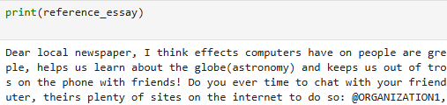
- Calculate and display word and sentence count from the reference essay
Test | Description | Expected Results |  | Actual Results
UT003 | Display Word Count | Number of words: 331 | Number of words: 331
UT004 | Display Sentence Count | Number of sentences: 16 | Number of sentences: 16

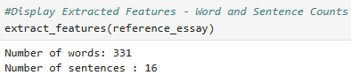
The natural language tool kit was used to tokenise sentences and words to provide a count that will later be used as a point of reference in determining the accuracy of the OCR detection and ASR transcription processes.
Purpose: Although these features will not contribute to the scoring of the essay by the transformer, they serve to satisfy the requirements for the system to be interpretable and explainable to human scorers.

- Calculate and display the word and sentence error rates
Test | Description | Expected Results |  | Actual Results
UT005 | Calculate and display the word error rate (WER) | Word Error Rate: 0.018 | Word Error Rate: 0.018
UT006 | Calculate and display the character error rate (CER) | Character Error Rate: 0.046 | Character Error Rate: 0.046

A copy of the reference essay was deliberately modified by appended the digit “5” to the first three and last three words of the first and last sentences. The ‘wer’ and ‘cer’ methods from the jiwer module were then used to calculate the word and character error rates.
Purpose: This was designed to test the accuracy of the calculate_error_rates() function, prior to the implementation of the OCR and ASR components. These metrics are essential to the operation of the evaluator functions in determining what output fed to the transformer for further processing or returned to the human scorer for manual scoring.
- Normalize the reference essay
Test | Description | Expected Results |  | Actual Results
UT007 | Convert a body of text to lower case | Essay successfully converted to lower case | Essay successfully converted to lower case
UT008 | Normalise symbols | Symbols normalised successfully | Symbols normalised successfully
UT009 | Normalise spoken forms | Spoken forms normalised successfully | Spoken forms normalised successfully
UT010 | Clean text by removing all punctuation and extra spaces | All punctuation and extra spaces successfully removed from text | All punctuation and extra spaces successfully removed from text

For efficiency, scalability and modularity, a class based approached – the EssayEditor class, was used to encapsulate the functions that will be applied to an essay to normalise it.
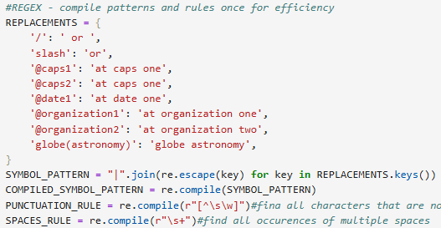
The researcher chose to use class attributes instead of instance variables for the normalisation process to conserve memory – each object will have its own copy of instance variables as compared to one set per class, available to all objects. This means that the normalisation process scales well as the number of input essays grows.
Some members of the sample use the spoken form slash to represent ‘/’, while others use ‘or’. The normalise () method of the EssayEditor class, substitutes these symbols with their spoken forms. This is to ensure that when applied to spoken essays from different speakers, the output is consistent after normalisation, making calculation of the CER and WER more accurate.
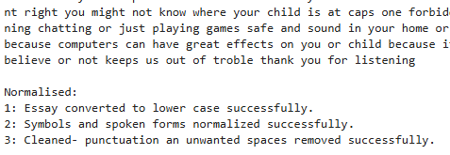
The screenshot above shows the output from the EssayEditor object its text – the reference essay, has been normalised. The object also prints confirmation of all successfully executed operations – when its show_edit_log() method is invoked.

5.3 Component Testing
Note: Most tests on the batch of handwritten essays for OCR evaluation, have been completed, however, the evaluation analysis is still outstanding. Also, experimentation to determine the best configuration to achieve the lowest wer and cer are also still outstanding.
See appendix B for Jupyter Notebook code if necessary or visit GitHub repo, see URL under test environment section.

- OCR: paddleOCR
- Recognition model: PP-OCRv6_medium_det
- Detection model: PP-OCRv6_medium_rec
Test environment: Jupyter Notebook
Test | Description | Expected Results | Actual Results
CT001 | Load paddleOCR model | Model loaded successfully. | Model loaded successfully.
CT002 | Load handwritten essay image | Image loaded successfully | Image loaded successfully
CT003 | Detect text regions | Text regions successfully detected | Text regions successfully detected
CT004 | Recognize handwritten text | Handwritten text successfully recognised | Handwritten text successfully recognised
CT005 | Calculate WER and CER | WER and CER successfully calculated | WER and CER successfully calculated
CT006 | Display OCR evaluation | Evaluation results successfully displayed | Evaluation results successfully displayed
- ASR: OpenAi Whisper
- Models: faster-whisper-base, faster-whisper-small, faster-whisper-medium
Test Objectives:
- Obtain the best performing model with respect to inference time, and storage footprint and transcription accuracy
- Determine if whisper’s transcriptions are acceptable to support its inclusion in the AES pipeline
Test | Description | Expected Results | Actual Results
CT007 | Access audio file(s) via specified path | Model loaded successfully. | Model loaded successfully.
CT008 | Load audio file to librosa for signal conversion | Audio loaded successfully | Audio loaded successfully
CT009 | Generate transcription for a single .wav file | Transcription performed successfully | Transcription performed successfully
CT010 | Load whisper model(s) | Models loaded successfully | Model loaded successfully
CT011 | Transcribe an audio recording | Recording successfully transcribed | Recording successfully transcribed
CT012 | Save model configuration and experiment data. | Model configuration and experiment data successfully saved | Model configuration and experiment data successfully saved
CT013 | Transcribe a batch of .wav spoken essay files | Batch of spoken essay files successfully transcribed | Batch of spoken essay files successfully transcribed
CT014 | Assign a transcription “pass” or “fail” based on its WER and CER values | Transcriptions successfully assigned “pass” or “fail” status based on WER and CER values | Transcriptions successfully assigned “pass” or “fail” status based on WER and CER values
CT015 | Save the WER and CER statistics for the batch of recordings | WER and CER statistics per batch saved | WER and CER statistics per batch saved

Selecting the best model along with the optimum parameter configuration. A list of six, 2-tuples – (model size, compute_type) parameter configurations were used to select the best model for the system.
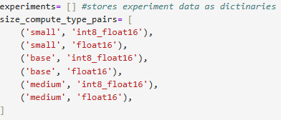
Thus, a total of 30 experiments – 5 per each model size, compute_type pair, were carried out. For each pair, transcription was done using beam sizes from 1 to 5 respectively. The results stored as a list of dictionaries are shown in the table below.
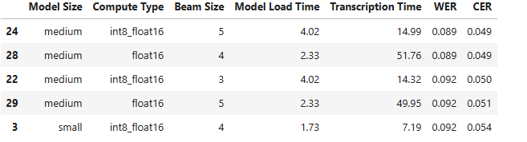
Experiments 24 and 28 achieved the same transcription accuracy. However, they differed noticeably in the time the model took to load. In experiment 24, mixed-precision quantization - int8_float16 was used, along with the beamsize=5. This model took roughly four (4) seconds to transcribe the audio.
The model in experiment 28, with beam size=4 and compute_type=float16, however, took about 50% less time to load but was more than three times slower than the model in experiment 24.
(Questions requiring answers)
Why was the VAD Filter set to True?
Why was the beam size adjusted?
Why were 16 threads alone used?
Why was CUDA fixed?
After the optimum configuration was implemented, the details dictionary was updated to include not only each file’s properties e.g. length and size along with the WER and CER for the transcription but also a “pass” or “fail” evaluation status. These values are assigned in relation to the WER and CER values exceeding the set threshold values of 0.099 and 0.059 respectively. These evaluation labels will be used later, to determine which transcriptions are forwarded to the transformer or human scorer for scoring.
A batch_transcription dictionary stores all individual transcription-detail dictionaries in a list along with WER, CER and evaluation statistics for the batch.
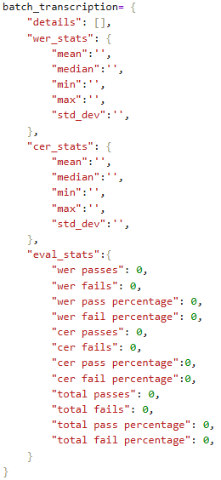
The rationale behind this design decision is to make possible the analysis of transcription statistics per individual transcription and per batch (e.g. a class of 25 students).
Although the WER and CER per batch are stored in the batch_transcription object, their calculation is not performed locally. The global calculate_stats function is invoked to perform these calculations. calculate_stats converts a list of individual transcription statistics to a numpy array and invokes numpy’s statistical functions to obtain an aggregate of the mean, median and so on. The function returns a dictionary with the calculated statistics. The rationale behind this design, is to avoid code redundancy – the OCR component also utilises the calculate_stats function.
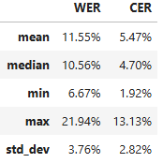
Evaluation of Whisper:
The mean WER, 11.55%, is slightly higher than the acceptable threshold of 9.0%. The max WER however, differs from the min by roughly 15 percentage points – indicating variation in transcription accuracy across the samples. The median WER, 10.56% is slightly above the threshold while the CER, 4.70%, is slightly below the threshold. Whisper transcribed 27 essays. 29.6% were within the acceptable bound and were classified as “pass”, which means that they will be scored by the transformer. The majority, however, more than double the percentage pass, were classified as “fail”, and will be assigned to the human scorer for scoring.
The number of essays classified as “fail”, due to a high WER is more than double that of those classified as “pass”. With respect CER the number of transcriptions that are classified as “pass” is roughly 10% more than those classified as “fail”. The model seems to more consistently get words wrong rather than individual letters or characters. There were 8/27 WER passes, 29.63% and 15/25 CER passes, 55.56%.
The most accurately transcribed essay has a WER of 6.67%, and a CER of less than 2%. Perusal of this essay after normalisation revealed that it is near perfect and that the errors in transcription did not detract from the semantic of the essay. An excerpt is shown below.
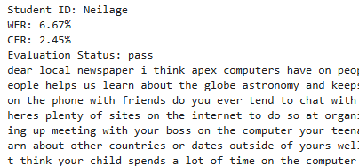
The essay with the median WER percentage has a WER slightly above the acceptable WER threshold, and a CER slightly below the acceptable threshold. 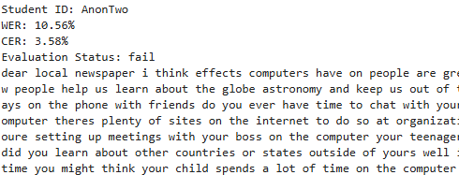
From a visual inspection of the normalised essay, it is apparent that most of the wrongly transcribed words are still decipherable by a human scorer. For example, Whisper transcribed “sea floor spreading” as
. This observation, however, does not motivate an adjustment to the current thresholds as this substitution, though recognisable to a human scorer, is likely to affect the transformer’s interpretation, resulting in an inaccurate score.
The screenshots below are from transcriptions with WER and CER percentages between the min and median and the median and max, respectively.
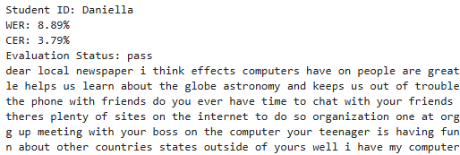
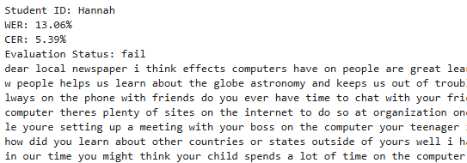
The transcription of Daniella voice is highly accurate with a WER of 8.89% and a CER of 3.79%. The transcription of Hannah although classified as “fail” is still readable and interpretable by a human scorer.
The most inaccurate transcription is still decipherable by a human scorer, as seen in the screenshot below.
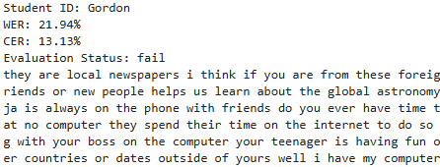
This indicates that the evaluation logic worked as intended, demonstrating sensitivity to transcriptions with high WER percentages, preventing them from moving through the pipeline.
This analysis supports the inclusion of Whisper in the AES pipeline as an assistive technology. However, the high proportion of failed transcriptions justifies the use of evaluation logic to route transcriptions to the appropriate scorer based on their WER and CER.
Transformer: DeBERTa
  - Model:
Test Environment: Jupyter Notebook
Test | Description | Expected Results | Actual Results
CT012 | Load model | The model loaded successfully
CT013 | Construct evaluation prompt | The evaluation prompt was successfully constructed
CT014 | Submit essay for scoring | The essay was successfully submitted for scoring
CT015 | Generate holistic score | A holistic score was generated successfully
CT018 | Generate trait scores (if possible) | Trait scores were successfully generated
CT016 | Generate feedback | Feedback was successfully generated
CT017 | Produce structured output (JSON or formatted response) | Output was structured successfully as JSON

5.4 Integration Testing

Test | Description | Expected Results | Actual Results
IT001 | Verify that OCR output is successfully passed to the transformer | The output was successfully passed to the transformer
IT002 | Verify that OCR evaluation metrics is successfully stored in the database | The output was successfully stored in the database
IT003 | Verify that ASR output is successfully passed to the transformer | The output was successfully passed to the transformer
IT004 | Verify that ASR evaluation metrics is successfully stored in the database | The output was successfully stored in the database
IT005 | Verify that the output from the transformer is successfully stored in the database | The output was successfully stored in the database
IT006 | Verify that the output from the transformer is successfully stored displayed to the user interface | The output was successfully displayed to the user interface

5.5 Functional System Testing

These tests are designed to evaluate the systems performance under real-world conditions.
Test | Description | Expected Results | Actual Results
FST001 | System accepts an image of written essay, paddleOCR extracts text, OCR Evaluator determines the text recognition accuracy to be acceptable and forwards essay to DeBERTa | Trait and holistic scores are displayed via the interface
FST002 | System accepts an audio file of a spoken essay, Whisper transcribes audio, ASR Evaluator determines  transcription accuracy to be acceptable and forwards essay to DeBERTa | Trait and holistic scores are displayed via the interface
FST003 | System accepts an image of written essay, paddleOCR extracts text, OCR Evaluator determines the text recognition accuracy to be unacceptable | User is alerted of the evaluation and directed to mark the essay manually
FST004 | System accepts an audio file of a spoken essay, Whisper transcribes audio, ASR Evaluator determines  transcription accuracy to be unacceptable | User is alerted of the evaluation and directed to mark the essay manually
FST005 | The system calculates the QWK after the transformer scores and essay | The system produced a QWK after the transformer scored the essay

5.6 End-User Testing
Test | Description | Expected Results | Actual Results
EUT001 | User can upload image of written essay | User successfully uploaded an image of a handwritten essay
EUT002 | User can upload audio recording of spoken essay | User successfully uploaded an audio file of a spoken essay
EUT003 | User can interpret trait and feature scores | User successfully interpreted feature scored
EUT004 | User can interpret holistic score | User successfully interpreted holistic score

5.7 Usability Testing

Statement | Strongly Disagree | Disagree | Neutral | Agree | Strongly Agree
The system is easy to use
The feedback is easy to understand
The scoring feedback is useful
The scoring feedback is verbose
The trait scores are reasonable
The holistic score is reasonable
The interface is well organised
The font size is appropriate
The colour scheme is clear
I would use this system again

Chapter 6

Conclusion and Future Improvements

Future improvements:

- The teacher should be able to mark an essay rejected by the OCR or ASR evaluators, via the user interface and save the changes to the database.
- The teacher should be shown the essay with tokens highlighted/selected (like easyOCR check notebook, include a screen shot if necessary), to demonstrate the detection capability of the OCR detection model
- The system should provide a list of all words identified by the recognition model along with their confidence scores.
- The system should allow a human scorer to assign confidence scored to words to improve the model’s recognition capabilities.
- The system should allow a human scorer to flag any words that are false positives. This data can be stored in a dictionary. This data can be used to train the model later.
- The system should be able to inform the student of the issues with the submission e.g. too dark or wrong angle or highlight words that have low confidence scores.
- The system should give suggestions for improving submissions e.g.
  - A word or series of words is illegible and requires rewriting, the system can highlight the objects and then suggest that the student rewrite more legibly for example in block letters or select letters from a software keyboard to identify the illegible letters.
- File conversion – accepting several different file formats to improve usability
- Combining interpretable features such as word count, sentence count, spelling errors with transformer output, or using them to engineer a trainable system.
- Merge images of essays submitted as separate files

Reference List

[1] W. Xu, R. Mahmud, and W. L. Hoo, "A Systematic Literature Review: Are Automated Essay Scoring Systems Competent in Real-Life Education Scenarios?" IEEE Access, vol. 12, pp. 77639–77657, 2024, doi: 10.1109/ACCESS.2024.3399163.
[2] K. Taghipour and H. T. Ng, "A Neural Approach to Automated Essay Scoring," in Proceedings of the 2016 Conference on Empirical Methods in Natural Language Processing (EMNLP), Austin, TX, USA, Nov. 2016, pp. 1882–1891, doi: 10.18653/v1/D16-1193.
[3] P. Lagakis and S. Demetriadis, "Automated Essay Scoring: A Review of the Field," in Proc. 2021 International Conference on Computer, Information and Telecommunication Systems (CITS), Istanbul, Turkey, Jul. 2021, pp. 1–5, doi: 10.1109/CITS52676.2021.9618476.
[4] J. Yang, "Automated Essay Scoring in Education," in Proc. 2024 4th International Conference on Educational Technology (ICET), 2024, pp. 170–175, doi: 10.1109/ICET62460.2024.10868446.
[5] A. M. Elmassry, N. Zaki, N. Alsheikh, and M. Mediani, "A Systematic Review of Pretrained Models in Automated Essay Scoring," IEEE Access, vol. 13, pp. 121902–121917, 2025, doi: 10.1109/ACCESS.2025.3584784.
[6] S. S. Han and M. Myint, "A Comparative Study of LSTM, Bi-LSTM, and BERT for Automated Essay Scoring," in Proc. [Insert Conference Name], [Year], pp. [pages], doi: [DOI].
[7] R. Dadi and S. K. Sanampudi, "A Robust Model for Automated Essay Scoring System," in Proc. 2024 International Conference on Computational Intelligence and Sustainable Engineering Solutions (CISES), 2024, pp. 1–6, doi: 10.1109/CISES62520.2024.10712145.
[8] P. Jain, K. Taneja, and H. Taneja, "Which OCR Toolset is Good and Why? A Comparative Study," in Proc. 2021 International Conference on Computational Performance Evaluation (ComPE), Shillong, India, 2021, pp. 640–646, doi: 10.1109/ComPE53109.2021.9752243.
[9] M. Li, T. Lv, J. Chen, L. Cui, Y. Lu, D. Florencio, C. Zhang, Z. Li, and F. Wei, "TrOCR: Transformer-Based Optical Character Recognition with Pre-trained Models," arXiv preprint arXiv:2109.10282, 2021.
[10] M. T. Mostafa, E. R. Rhythm, M. H. K. Mehedi, and A. A. Rasel, "Advancements in Optical Character Recognition for Bangla Scripts," in Proc. 2023 International Conference on Electrical, Computer and Communication Engineering (ECCE), 2023, pp. 1–6.
[11] R. Hussain, A. Raza, I. Siddiqi, K. Khurshid, and C. Djeddi, "A comprehensive survey of handwritten document benchmarks: Structure, usage and evaluation," EURASIP Journal on Image and Video Processing, vol. 2015, Art. no. 46, 2015, doi: 10.1186/s13640-015-0102-5.
[12] A. K. Meghana, H. Gupta, and P. Dubey, "Enhanced Text Extraction from Low-Quality Legacy Documents Using TrOCR Assisted by Line Detection," in Proc. 8th World Engineering Conference on Contemporary Technologies (WECON), 2025, doi: 10.1109/WECON68556.2025.11414621.
[13] J. Q. Cheok, K. C. Lim, and C. E. Si, "Maximizing Recognition Reliability: TrOCR Outperforms PaddleOCR in Challenging Container Automation Environments," International Journal of Research and Innovation in Social Science (IJRISS), vol. 9, no. 11, 2025, Art. no. 91100629, doi: 10.47772/IJRISS.2025.91100629.
[14] B. Wang, T. Zhao, L. Dong, Z. Yu, and Y. Qian, "Application of PaddleOCR in Power Consumption Environment Text Recognition," in Proc. 7th Int. Academic Exchange Conf. on Science and Technology Innovation (IAECST), 2025, pp. 1562–1566, doi: 10.1109/IAECST68792.2025.11415173.
[15] A. Elakkiya, K. Jaya Surya, K. Venkatesh, and S. Aakash, "Implementation of Speech to Text Conversion Using Hidden Markov Model," in Proc. 2023 International Conference on Intelligent Computing and Control Systems (ICICCS), 2023, pp. 1–5.
[16] M. S. Tabrej, K. J. Deb, M. A. Hakim, and S. Goswami, "Automatic Speech Recognition in the Modern Era: Architectures, Training, and Evaluation," in Proc. 2023 International Conference on Artificial Intelligence and Data Engineering (AIDE), 2023, pp. 1–6.
[17] G. Hinton, L. Deng, D. Yu, G. E. Dahl, A.-r. Mohamed, N. Jaitly, A. Senior, V. Vanhoucke, P. Nguyen, T. N. Sainath, and B. Kingsbury, "Deep Neural Networks for Acoustic Modeling in Speech Recognition," IEEE Signal Processing Magazine, vol. 29, no. 6, pp. 82–97, 2012, doi: 10.1109/MSP.2012.2205597.
[18] A. Radford, J. Kim, T. Xu, G. Brockman, C. McLeavey, and I. Sutskever, "Robust Speech Recognition via Large-Scale Weak Supervision," arXiv preprint arXiv:2212.04356, 2022.
[19] A. Vaswani, N. Shazeer, N. Parmar, J. Uszkoreit, L. Jones, A. N. Gomez, Ł. Kaiser, and I. Polosukhin, "Attention Is All You Need," in Advances in Neural Information Processing Systems (NeurIPS), 2017, pp. 5998–6008.
[20] K. Hlongwane, S. Mthethwa, and L. Manqele, "Enhancing Diversity in Inclusive Learning Classroom Using OpenAI Whisper Model," in IST-Africa 2025 Conference Proceedings, M. Cunningham and P. Cunningham, Eds., IST-Africa Institute and IIMC, 2025, ISBN: 978-1-905824-75-5.
[21] J. Su, Y. Yan, Z. Gao, H. Zhang, X. Liu, and X. Hu, "Multi-Granular Multimodal Essay Scoring," arXiv preprint arXiv:2505.13965, 2025.
[22] A. Algablan, R. Alshammari, and S. Alresaini, "Scoring Students' Answers Using OCR and GPT," in Proc. 2026 IEEE 5th International Conference on Computing and Machine Intelligence (ICMI), 2026, doi: 10.1109/ICMI68585.2026.11539856.
[23] J. Gao, Q. Yang, Y. Zhang, L. Zhang, and S. Wang, "A Bi-modal Automated Essay Scoring System for Handwritten Essays," in Proceedings of the 2021 International Joint Conference on Neural Networks (IJCNN), 2021, doi: 10.1109/IJCNN52387.2021.9533505.
[24] C. A. L. Baclayon, K. O. R. Costelo, J. J. L. Flores, and C. L. C. Sta. Romana, "Automated Handwritten Essay Evaluation in Moodle: Leveraging Google Vision OCR and Mistral 7B," in Proceedings of ICDTE 2024, ACM, Berlin, Germany, Aug. 07–09, 2024, doi: 10.1145/3696230.3696256.
[25] Y. Wang, W. Qu, and X. Ye, "Selecting Between BERT and GPT for Text Classification in Political Science Research," arXiv preprint arXiv:2411.05050, Nov. 2024, doi: 10.48550/arXiv.2411.05050.
[26] P. He, X. Liu, J. Gao, and W. Chen, "DeBERTa: Decoding-Enhanced BERT with Disentangled Attention," in Proc. International Conference on Learning Representations (ICLR), 2021.
[27] D. K. A, A. V. S, R. Aravindan, and A. Balamurali, "Sound Sight-A TTS and STT Integrated Model using OCR and ASR," in 2024 International Conference on Innovative Computing, Intelligent Communication and Smart Electrical Systems (ICSES), Chennai, India, Dec. 2024, pp. 1–5, doi: 10.1109/ICSES63760.2024.10910492.
[28] J. C. Obi, "A comparative study of several classification metrics and their performances on data," World Journal of Advanced Engineering Technology and Sciences, vol. 8, no. 1, pp. 308–314, Feb. 2023, doi: 10.30574/wjaets.2023.8.1.0054.
[29] S. Sathyanarayanan and B. R. Tantri, "Confusion matrix-based performance evaluation metrics," African Journal of Biomedical Research, vol. 27, no. 4S, pp. 4023–4031, Nov. 2024, doi: 10.53555/AJBR.v27i4S.4345.
[30] G. M. Foody, "Challenges in the real-world use of classification accuracy metrics: From recall and precision to the Matthews correlation coefficient," PLoS ONE, vol. 18, no. 10, Art. no. e0291908, Oct. 2023, doi: 10.1371/journal.pone.0291908.
[31] A. N. Chowdhury, S. Absar, A. A. Sami, F. Rahman, S. M. P. Mamun, and M. S. R. Kohinoor, "Performance analysis of Tesseract and EasyOCR for Bangla optical character recognition on the novel Bangla CrossHair dataset," in Proc. 2025 3rd Int. Conf. on Intelligent Systems, Advanced Computing and Communication (ISACC), 2025, pp. 1–6, doi: 10.1109/ISACC65211.2025.10969286.
[32] M. A. N. Hadi, M. Gul, M. Khan, G. N. Alwakid, and N. Z. Jhanjhi, "Benchmarking performance analysis of optical character recognition techniques," in Proc. 26th Int. Multitopic Conf. (INMIC), Karachi, Pakistan, Dec. 2024, pp. 1–6, doi: 10.1109/INMIC64792.2024.11004392.

Appendix A - Consent Forms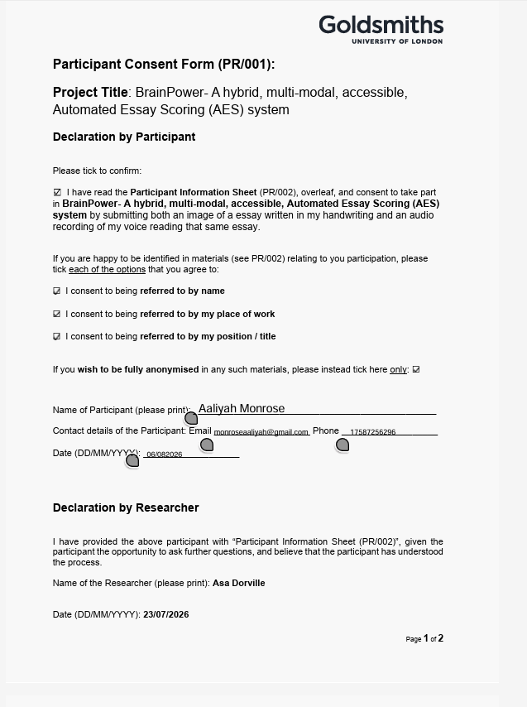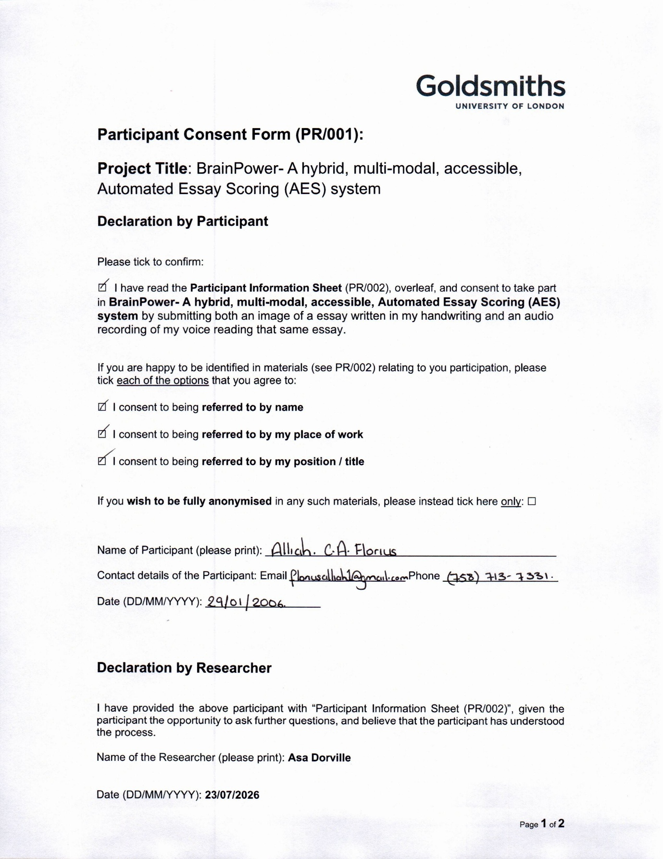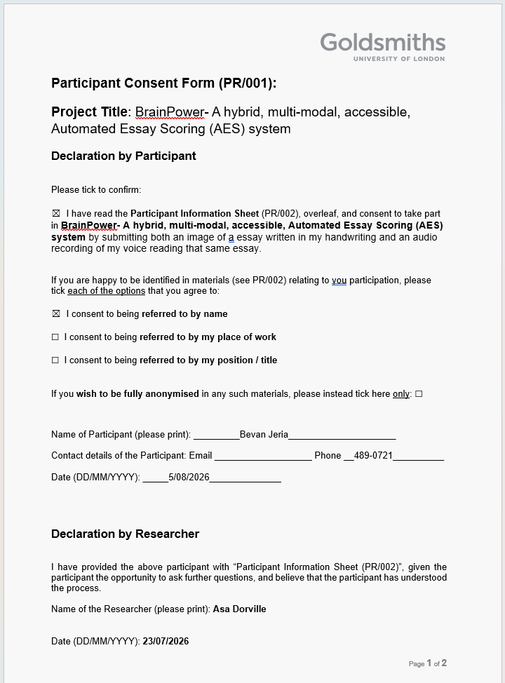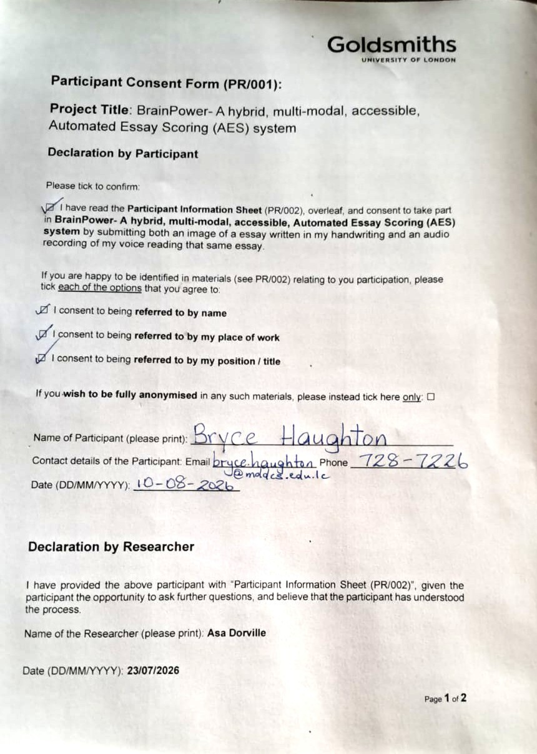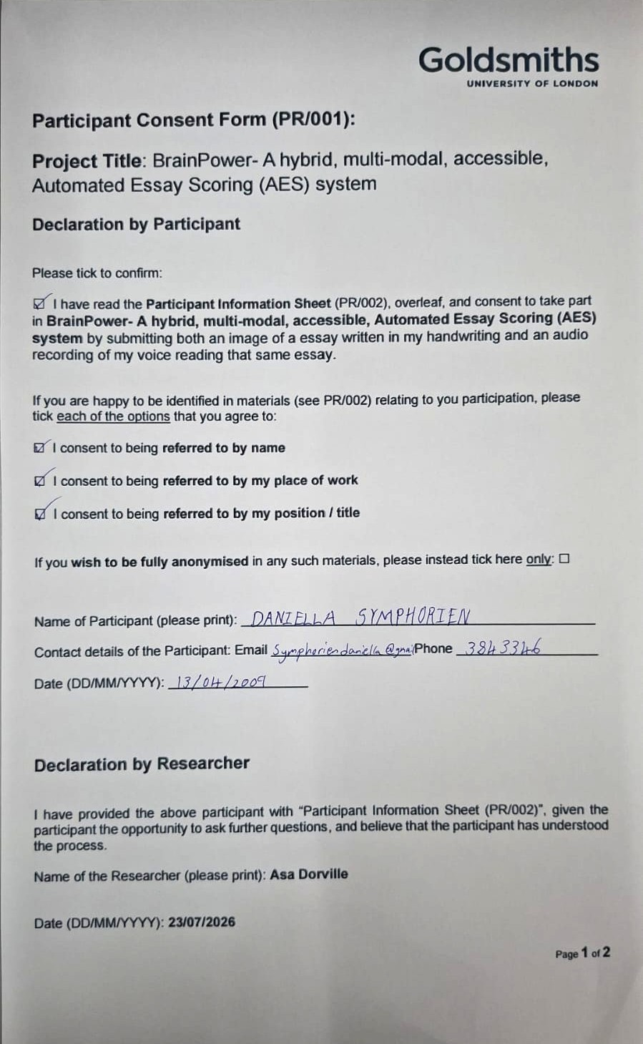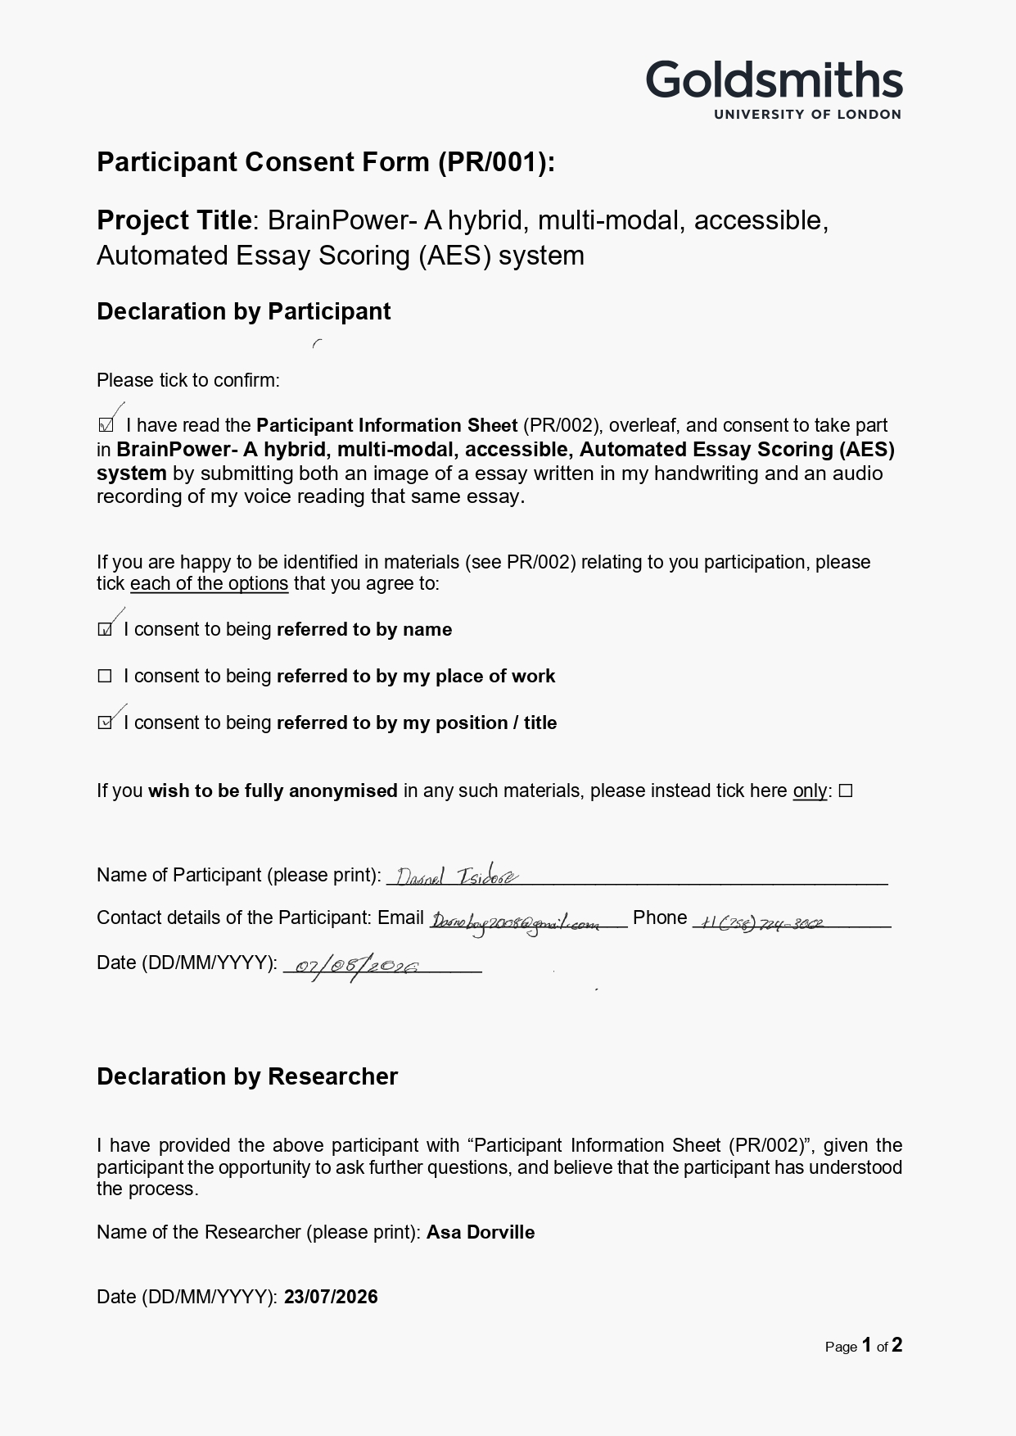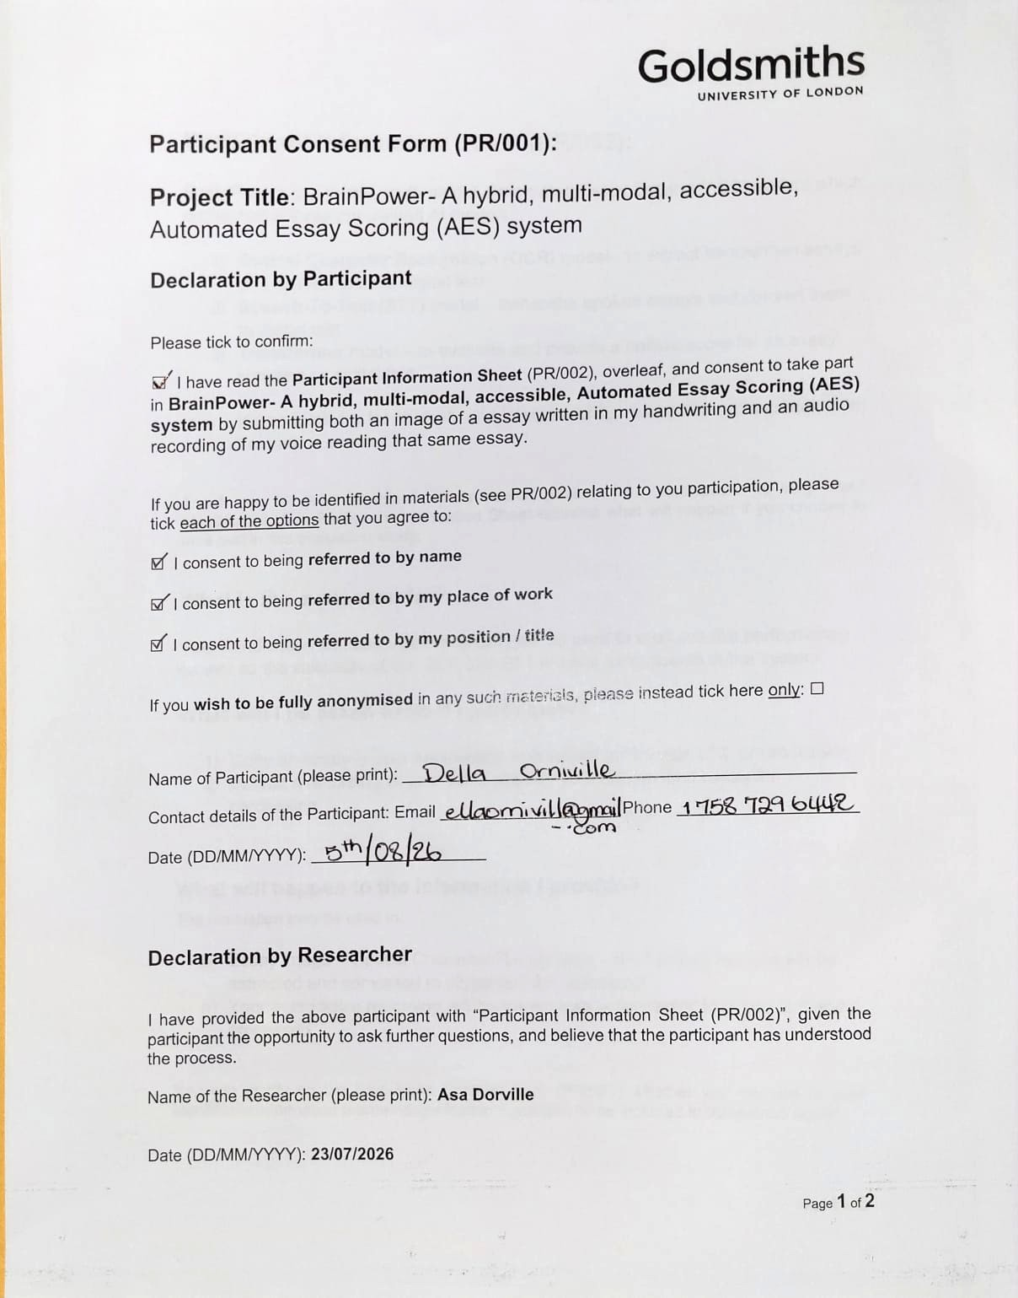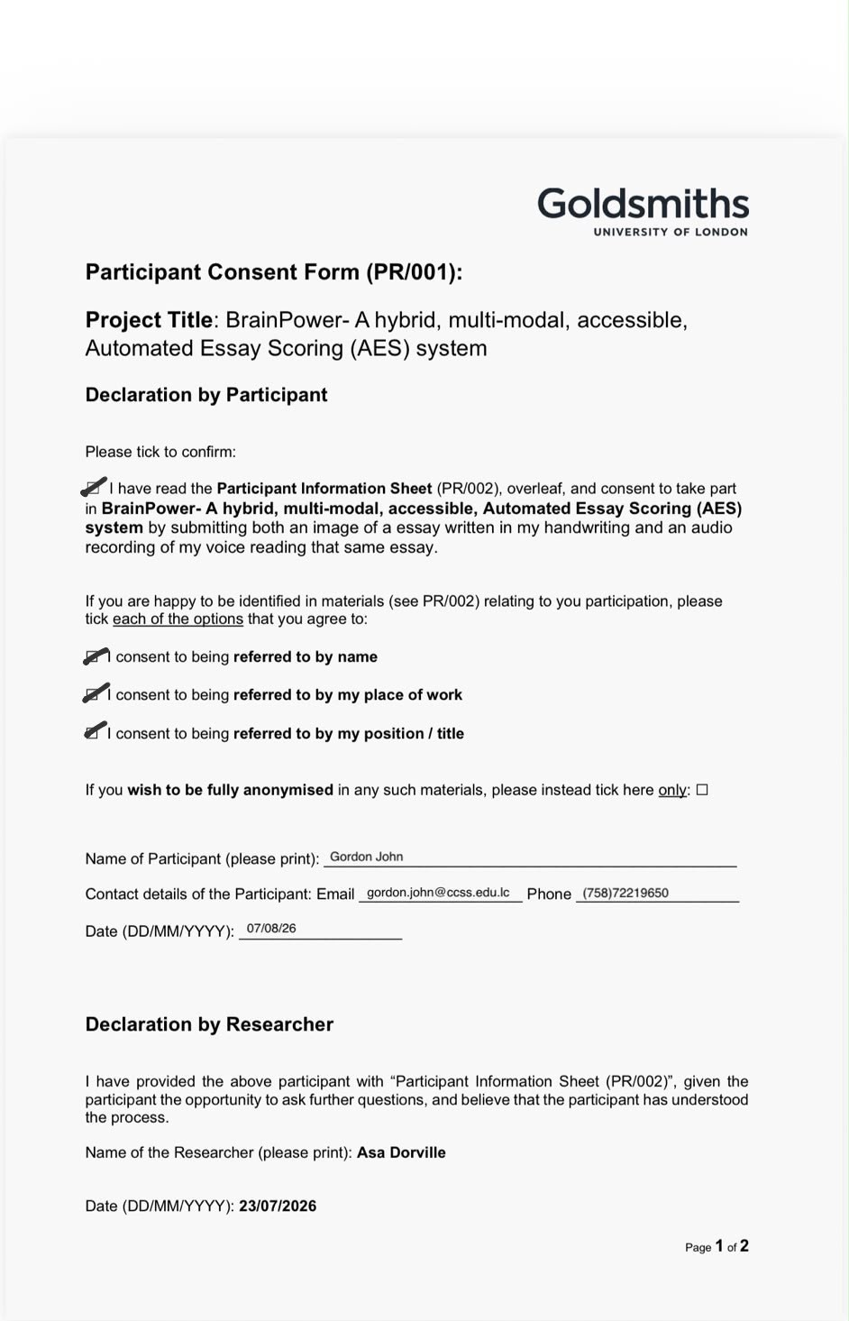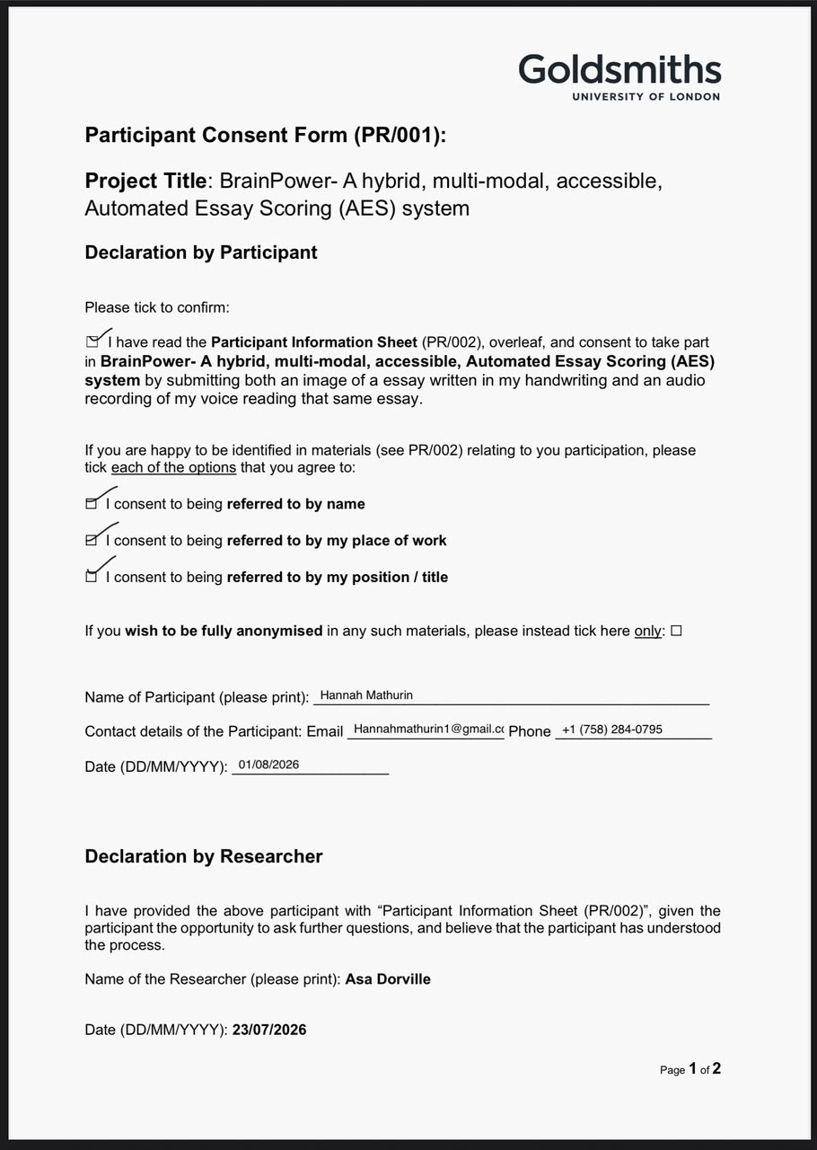

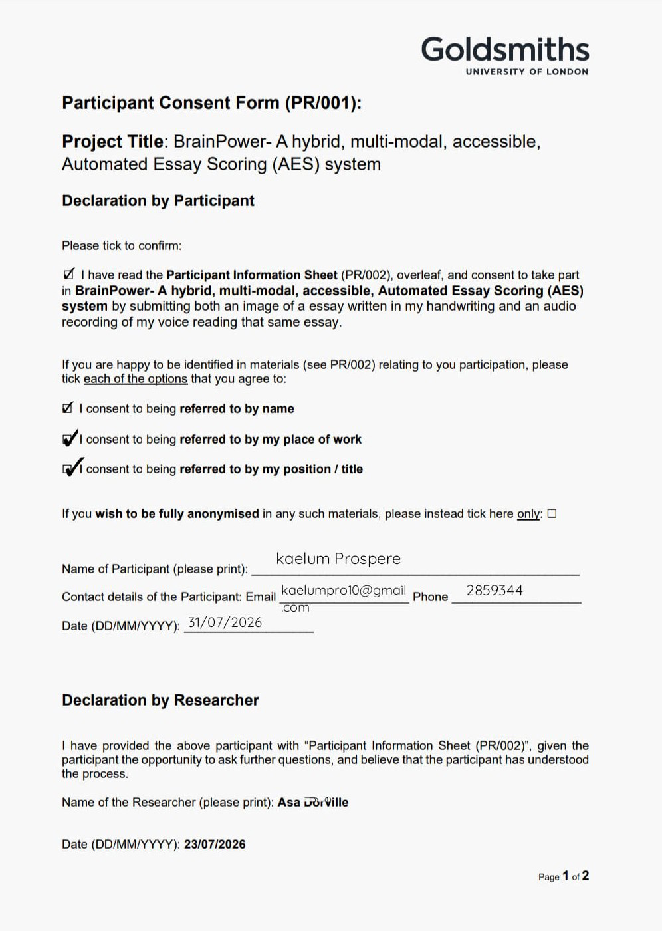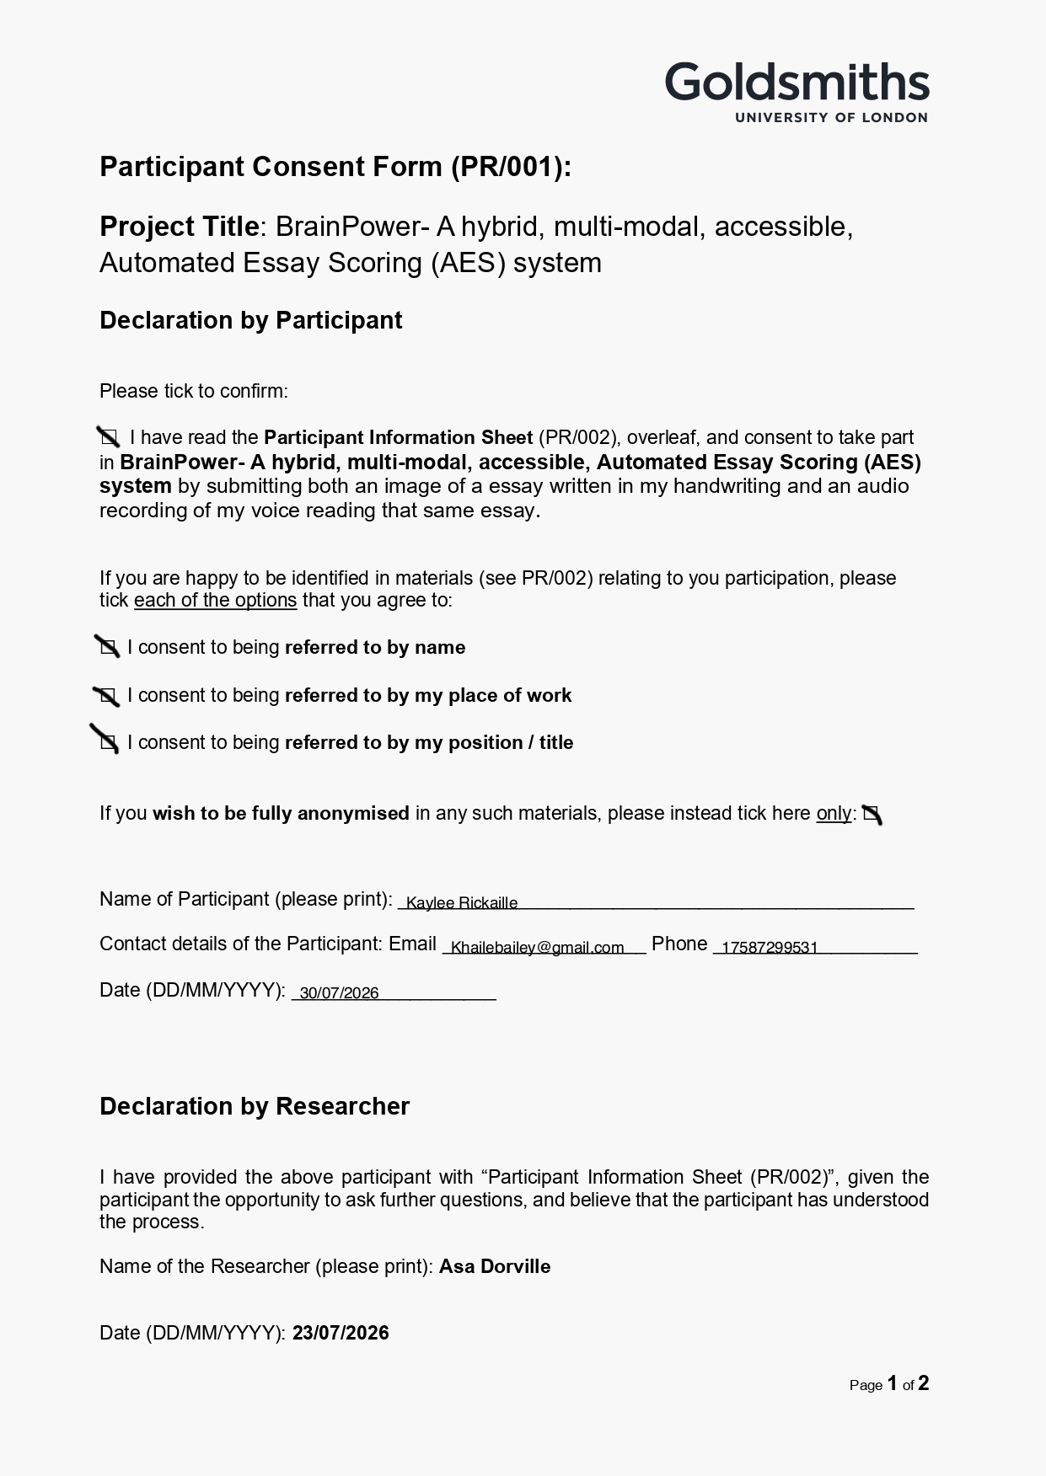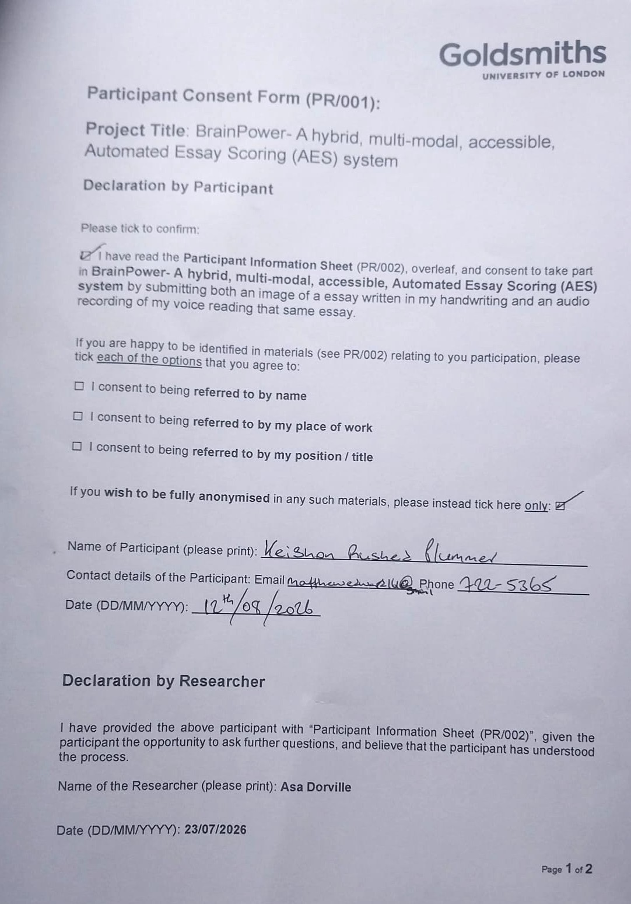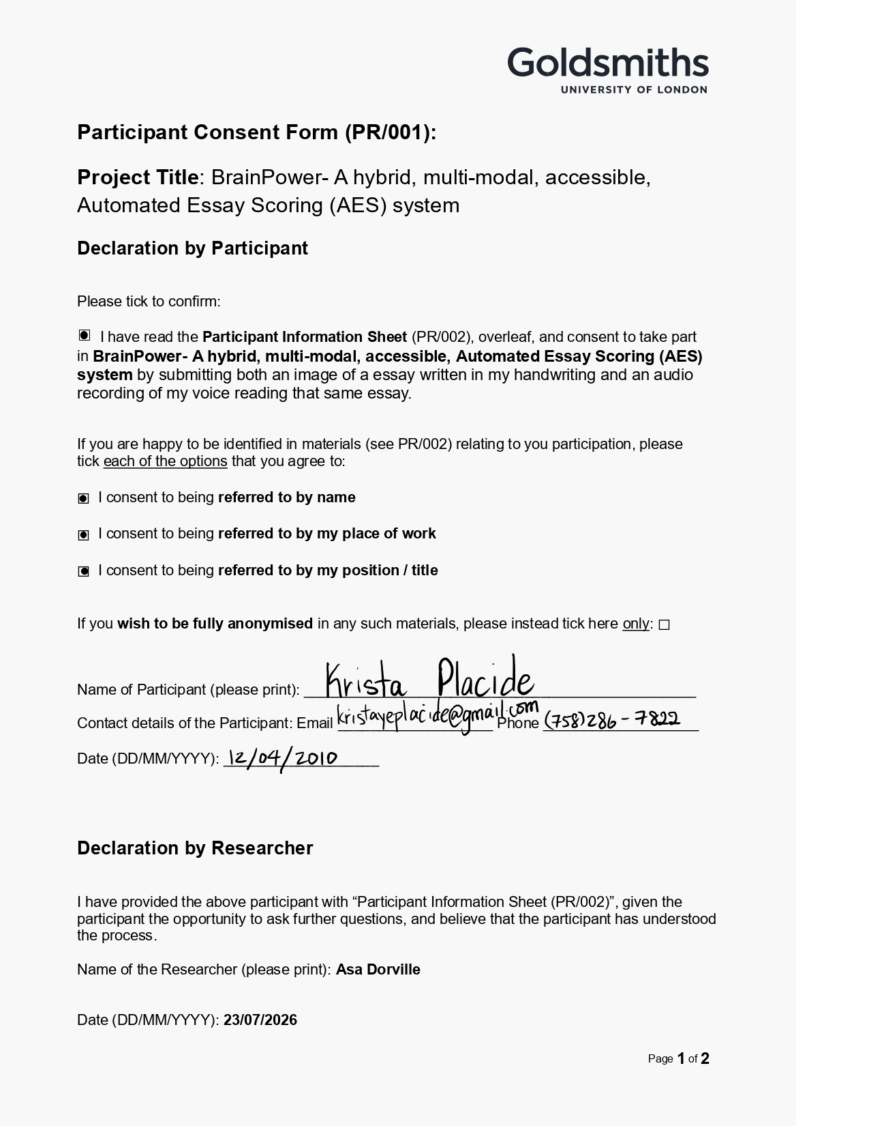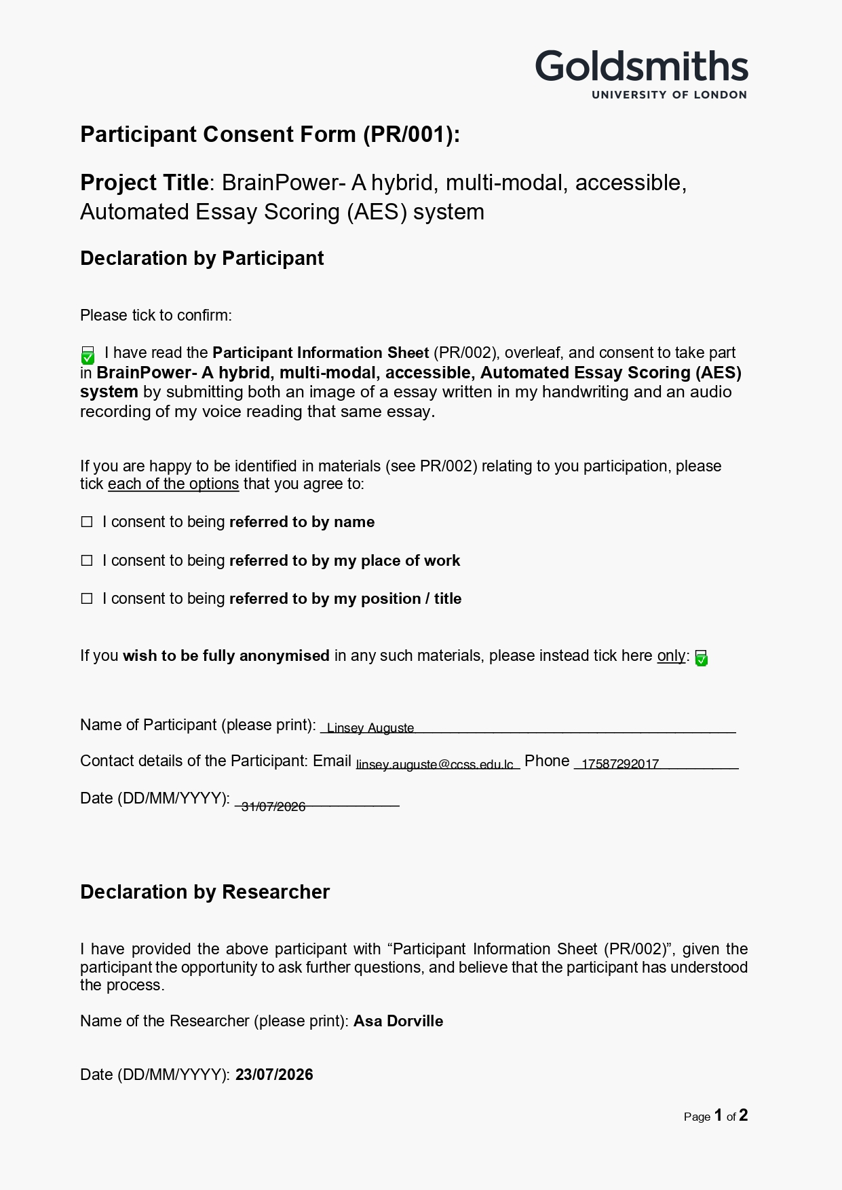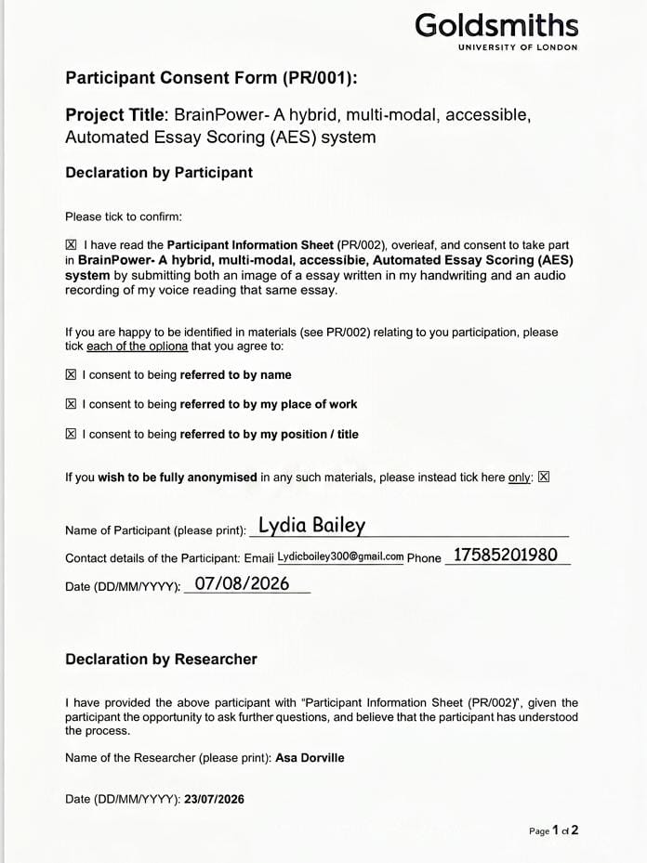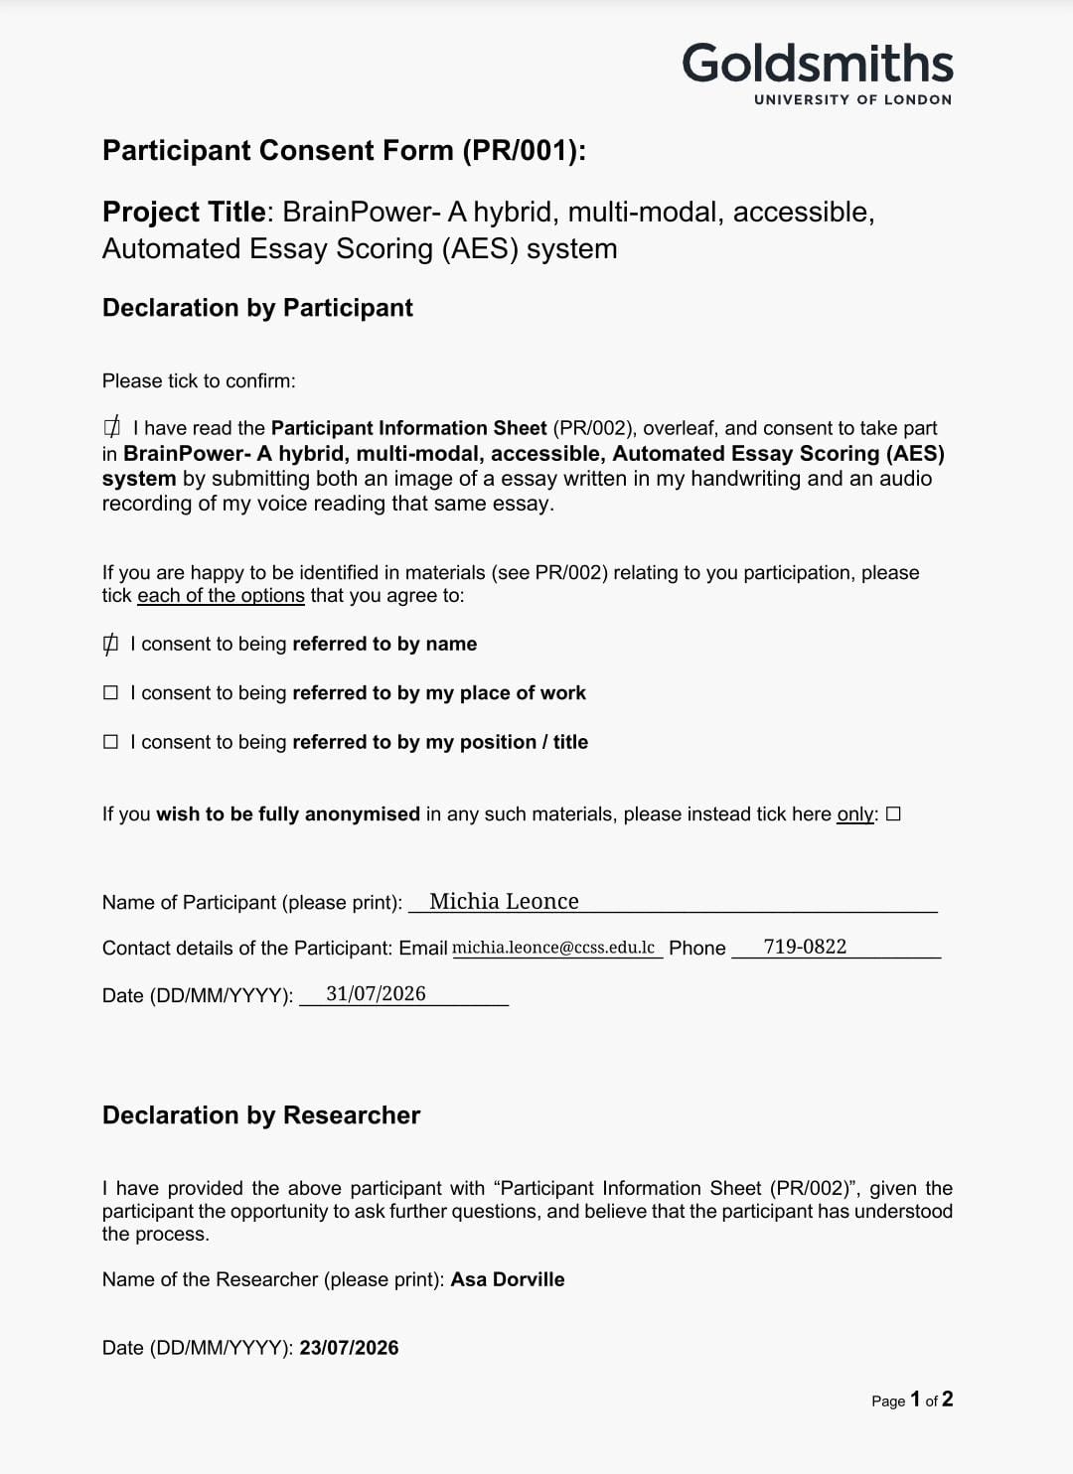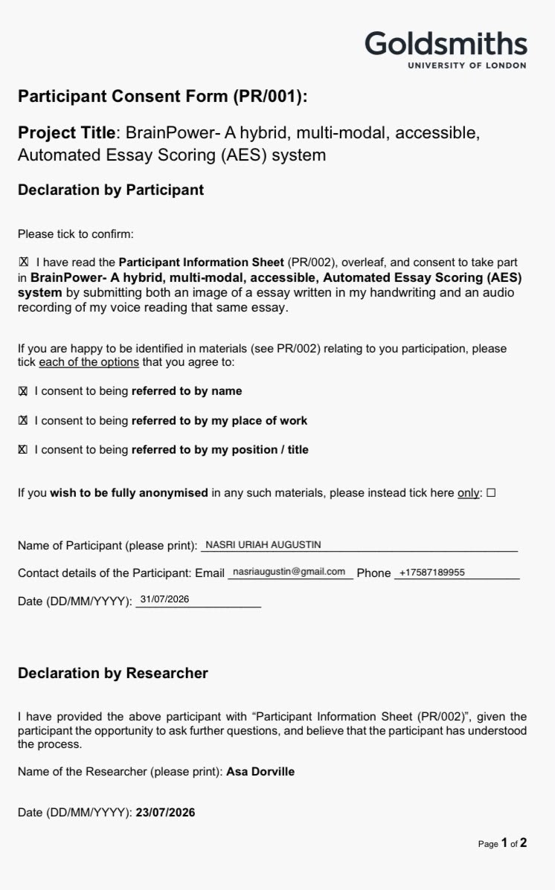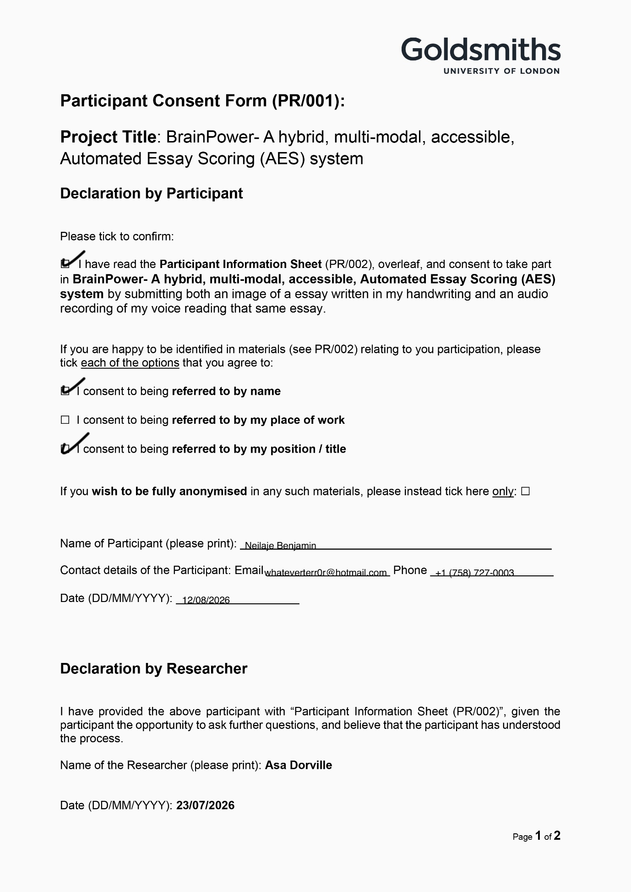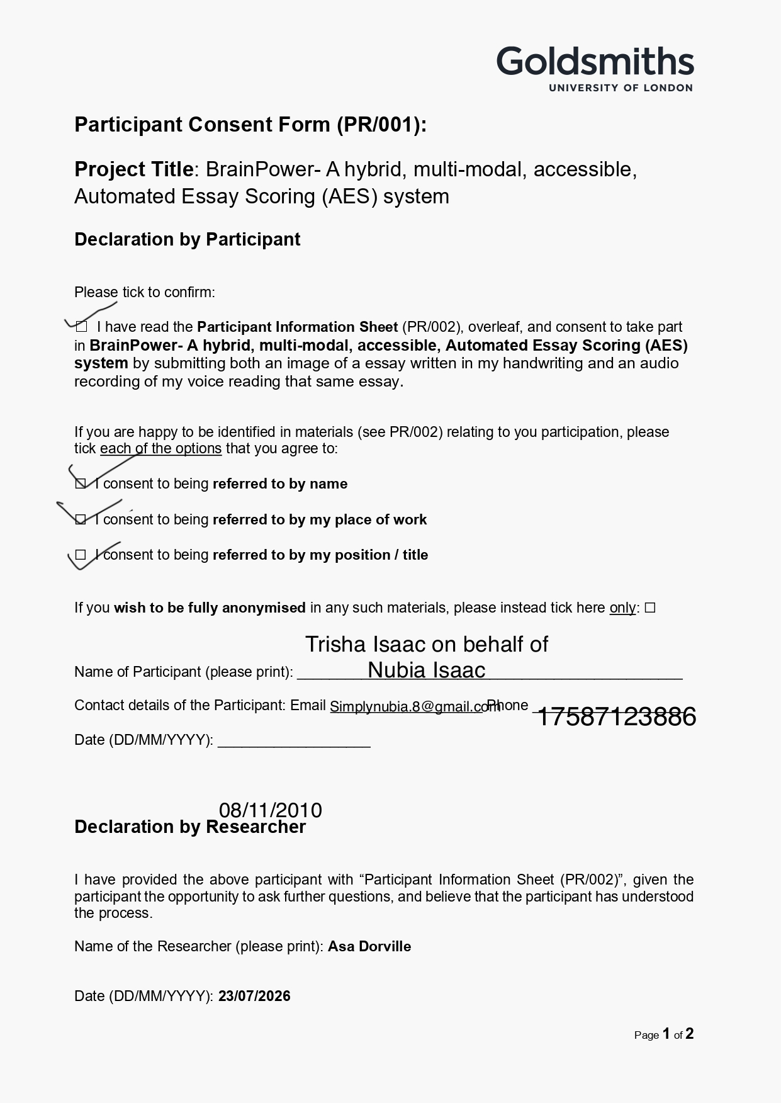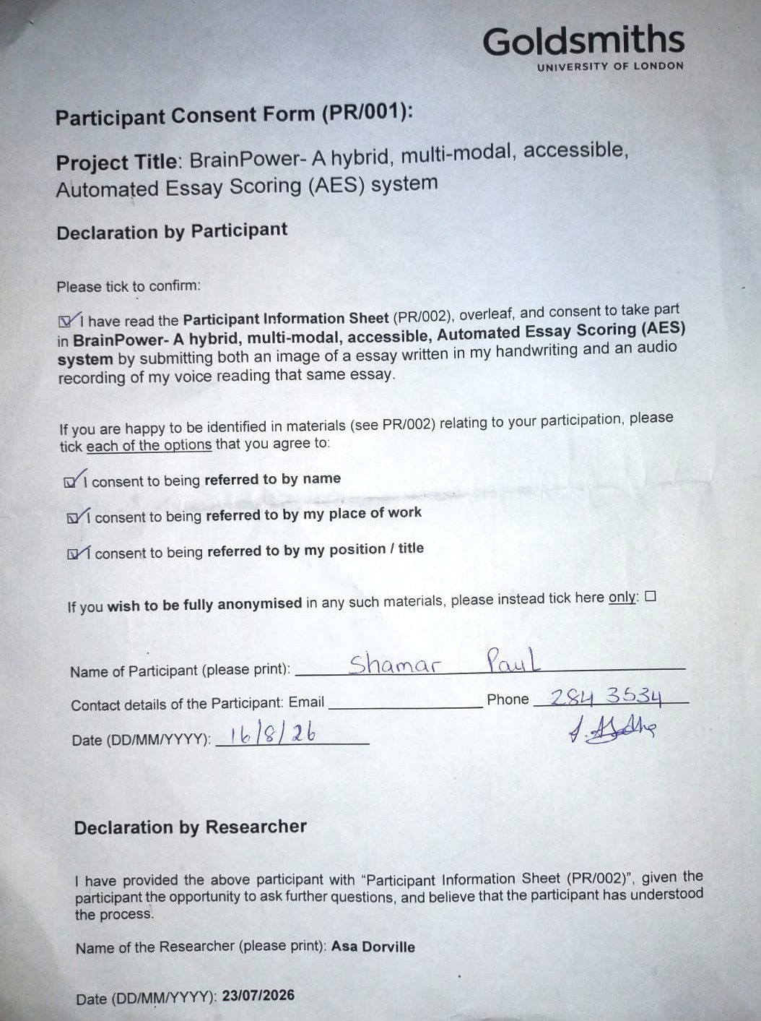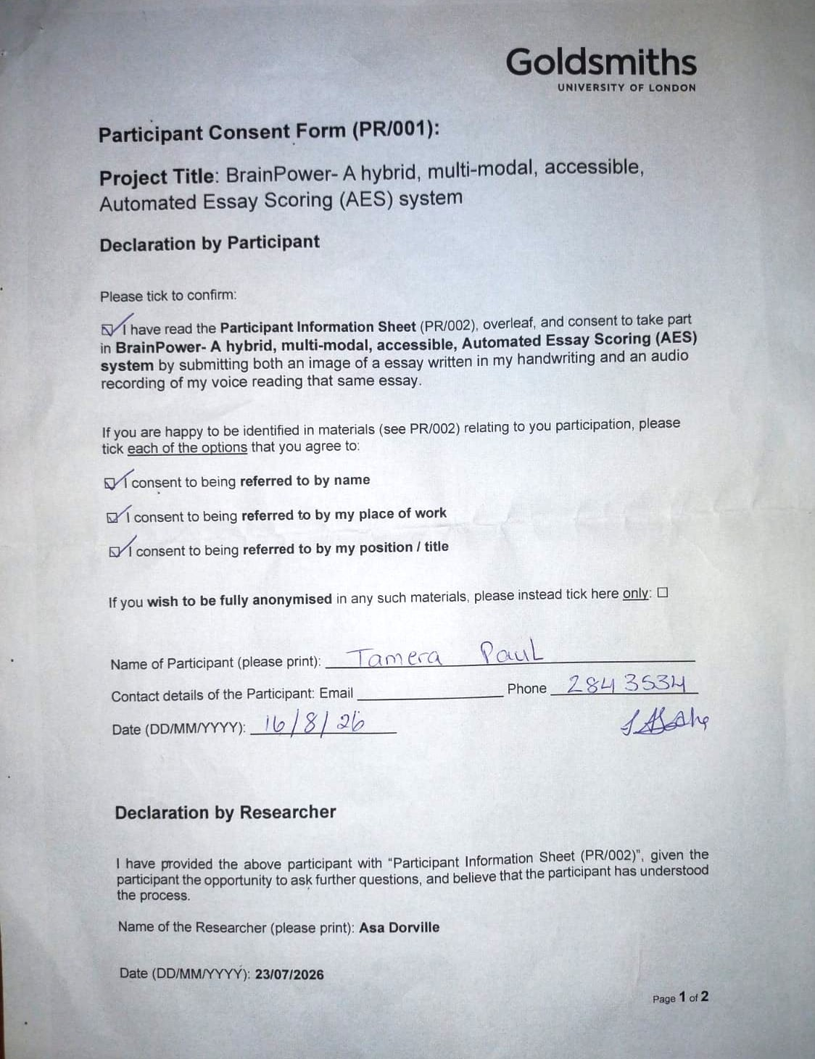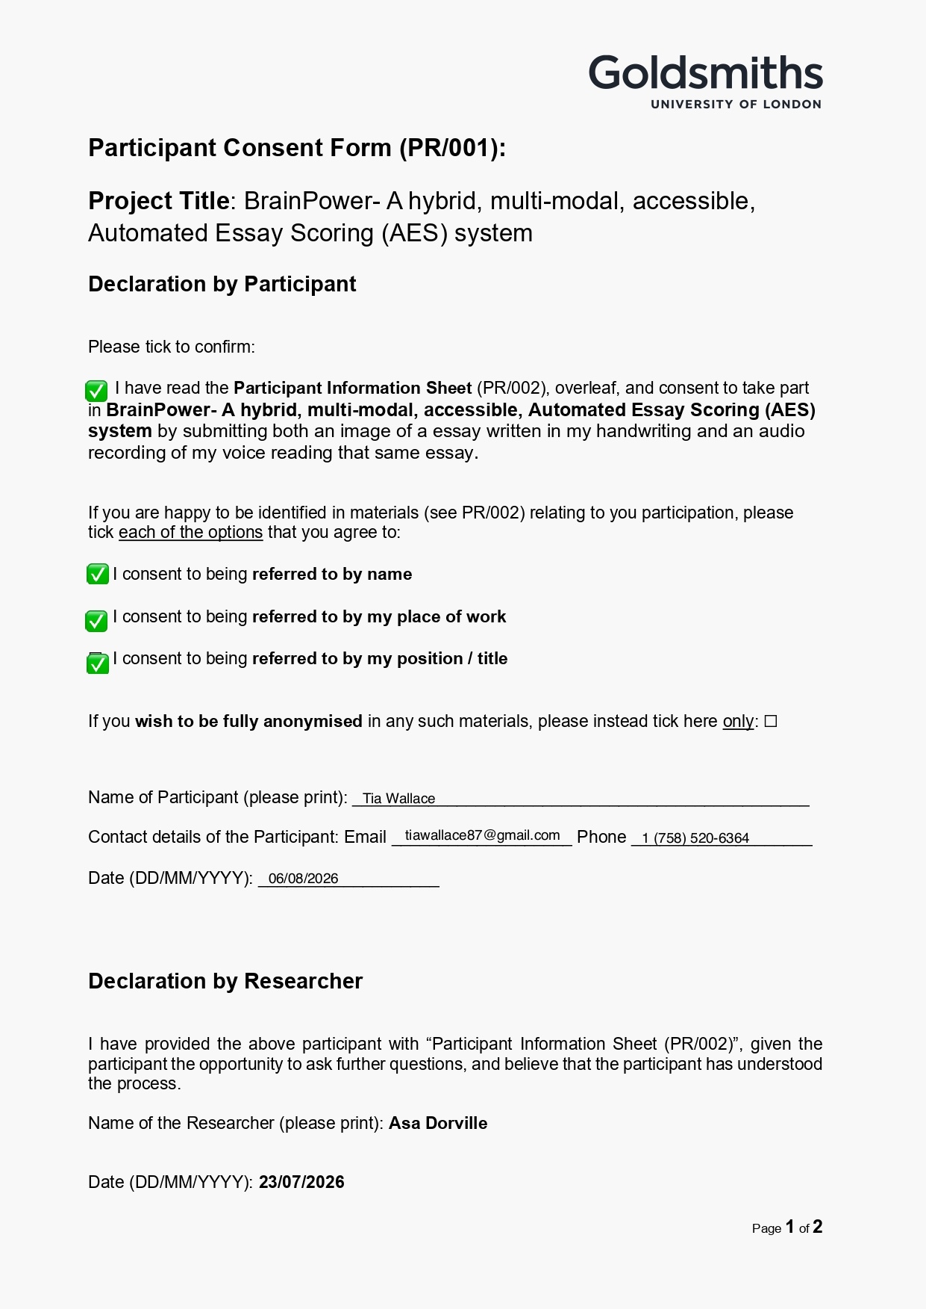

Appendix B – Project Code – Jupyter Notebook

Testing BrainPower AES System
The purpose of this notebook is to:
- Test the ASR and OCR components to justify their inclusion in the AES pipeline to provide accessibility and inclusion
- Test the Transformer component to determine its suitability for providing assistance to human scorers

The Prompt
prompt = """More and more people use computers, but not everyone agrees that this benefits society.
Those who support advances in technology believe that computers have a positive effect on people.
They teach hand-eye coordination, give people the ability to learn about faraway places and people,
and even allow people to talk online with other people. Others have different ideas. Some experts
are concerned that people are spending too much time on their computers and less time exercising,
enjoying nature, and interacting with family and friends.

Write a letter to your local newspaper in which you state your opinion on the effects computers have
on people. Persuade the readers to agree with you."""

Rubric Guidelines
import pandas as pd
df = pd.read_csv("./data/rubric guidelines.csv", encoding="utf-8")
df[:]
Output:
 | score | description | typical element 1 | typical element 2 | typical element 3 | typical element 4
0 | 1 | An undeveloped response that may take a positi... | Contains few or vague details. | Is awkward and fragmented. | May be difficult to read and understand. | May show no awareness of audience.
1 | 2 | An under-developed response that may or may no... | Contains only general reasons with unelaborate... | Shows little or no evidence of organization. | May be awkward and confused or simplistic. | May show little awareness of audience.
2 | 3 | A minimally-developed response that may take a... | Has reasons with minimal elaboration and more ... | Shows some organization. | May be awkward in parts with few transitions. | Shows some awareness of audience.
3 | 4 | A somewhat-developed response that takes a pos... | Has adequately elaborated reasons with a mix o... | Shows satisfactory organization. | May be somewhat fluent with some transitional ... | Shows adequate awareness of audience.
4 | 5 | A developed response that takes a clear positi... | Has moderately well elaborated reasons with mo... | Exhibits generally strong organization. | May be moderately fluent with transitional lan... | May show a consistent awareness of audience.
5 | 6 | A well-developed response that takes a clear a... | Has fully elaborated reasons with specific det... | Exhibits strong organization. | Is fluent and uses sophisticated transitional ... | May show a heightened awareness of audience.

Method for Feature Extraction and Accuracy Metrics
import nltk
nltk.download('punkt_tab')
from jiwer import wer, cer, process_words
import re
from pathlib import Path
import numpy as np
import copy

class EssayEditor: #4/aug/2026
"""This class normalizes a body of text and can display the body of text along with
its word and sentence counts.
"""
#REGEX - compile patterns and rules once for efficiency
REPLACEMENTS = {
'/': ' or ',
'slash': 'or',
'@caps1': 'at caps one',
'@caps2': 'at caps one',
'@date1': 'at date one',
'@organization1': 'at organization one',
'@organization2': 'at organization two',
'globe(astronomy)': 'globe astronomy',
}
SYMBOL_PATTERN = "|".join(re.escape(key) for key in REPLACEMENTS.keys())
COMPILED_SYMBOL_PATTERN = re.compile(SYMBOL_PATTERN)
PUNCTUATION_RULE = re.compile(r"[^\s\w]")#fina all characters that are not words or spaces
SPACES_RULE = re.compile(r"\s+")#find all occurences of multiple spaces

def __init__(self, text):
self.text = text
self.original_text=copy.copy(text)
self.edit_log = []#stores record of successful exection
self.is_normalised = False
sentences = nltk.tokenize.sent_tokenize(self.text)
sentence_count = len(sentences)
#Taken prior to normalization which removes sentence punctuation
self.sentence_count = sentence_count

def normalise(self):
self.text = self.text.lower()
self.edit_log.append("Essay converted to lower case successfully.")
# Normalise spoken forms and symbol
self.text = self.COMPILED_SYMBOL_PATTERN.sub(
lambda match: self.REPLACEMENTS[match.group(0)],
self.text
)
self.edit_log.append("Symbols and spoken forms normalized successfully.")
#Clean text
#Replace all non-words or non-spaces with an empty string
self.text = self.PUNCTUATION_RULE.sub("", self.text)
#Replace all spaces with a single space, then remove unwanted spaces
self.text = self.SPACES_RULE.sub(" ", self.text).strip()
self.edit_log.append("Cleaned- punctuation an unwanted spaces removed successfully.")
self.is_normalised = True

def get_sentence_count(self):
return self.sentence_count

def get_text(self) -> str:#use type hint
return self.text

def get_word_count(self):
words= nltk.tokenize.word_tokenize(self.text)
words = [word for word in words if word.isalnum()]
word_count= len(words)
return word_count

def show_normalised_text(self):
print(self.text)

def show_original_text(self):
print(self.original_text)

def show_edit_log(self):
if self.is_normalised:
print("\nNormalised:")
for i, log in enumerate(self.edit_log,1):
print(f"{i}: {log}")
else:
print("\nEssay not normalised")

def get_files_metadata(path_to_folder):
"""This function returns a list of the paths, filenames and extensions for
all files in a folder.
Path must be imported from pathlib
"""
files_metadata = []
#Folder with audio files
folder = Path(path_to_folder)
for file in folder.iterdir():#Returns Path object
if file.is_file():
#Get file path
path = str(file)
#Get file exension
extension = file.suffix
#Get file name/student's name
name = file.stem
#Get file size in bytes convert to mb
size = round(file.stat().st_size/(1024**2), 2)
#Add to list
files_metadata.append({
"path":path,
"extension": extension,
"name":name,
"size":size
})
return files_metadata

def calculate_stats(list_of_nums):
"""This function takes as agrument and used numpy to calculates,
the mean, median, min, max, std_dev of a list. It returns a
dict.
"""
#Convert to numpy array
vals= np.array(list_of_nums)
stats = {
#Calculate mean
"mean": f"{vals.mean():.2%}",
#Calculate median
"median": f"{np.median(vals):.2%}",
#Calculate min
"min": f"{vals.min():.2%}",
#Calculate max
"max": f"{vals.max():.2%}",
#Calculate std_dev
"std_dev": f"{vals.std():.2%}"
}
return stats

# Calculate WER and CER -----------adapted from ChapGPT
def calculate_error_rates(reference_essay, component_output):
word_error_rate = wer(reference_essay, component_output)
character_error_rate = cer(reference_essay, component_output)
return {
"wer": word_error_rate,
"cer":character_error_rate
}
Output:
[nltk_data] Downloading package punkt_tab to
[nltk_data] C:\Users\cowse\AppData\Roaming\nltk_data...
[nltk_data] Package punkt_tab is already up-to-date!

Unit Testing
# UT001 - Importing the ASAP 1.0 dataset
df = pd.read_csv(
"./data/asap/training_set_rel3.tsv",
sep="\t",
encoding="latin-1"
)
df.head()
Output (5 rows × 28 columns, first 9 columns shown):
essay_id | essay_set | essay | rater1_domain1 | rater2_domain1 | rater3_domain1 | domain1_score | rater1_domain2 | rater2_domain2
0 | 1 | 1 | Dear local newspaper, I think effects computer... | 4 | 4 | NaN | 8 | NaN
1 | 2 | 1 | Dear @CAPS1 @CAPS2, I believe that using compu... | 5 | 4 | NaN | 9 | NaN
2 | 3 | 1 | Dear, @CAPS1 @CAPS2 @CAPS3 More and more peopl... | 4 | 3 | NaN | 7 | NaN
3 | 4 | 1 | Dear Local Newspaper, @CAPS1 I have found that... | 5 | 5 | NaN | 10 | NaN
4 | 5 | 1 | Dear @LOCATION1, I know having computers has a... | 4 | 4 | NaN | 8 | NaN
#Get structure of dataset
df.columns.tolist()
Output:
['essay_id',
'essay_set',
'essay',
'rater1_domain1',
'rater2_domain1',
'rater3_domain1',
'domain1_score',
'rater1_domain2',
'rater2_domain2',
'domain2_score',
'rater1_trait1',
'rater1_trait2',
'rater1_trait3',
'rater1_trait4',
'rater1_trait5',
'rater1_trait6',
'rater2_trait1',
'rater2_trait2',
'rater2_trait3',
'rater2_trait4',
'rater2_trait5',
'rater2_trait6',
'rater3_trait1',
'rater3_trait2',
'rater3_trait3',
'rater3_trait4',
'rater3_trait5',
'rater3_trait6']
#Get Statistics
df["essay_set"].value_counts().sort_index()
Output:
essay_set
1 1783
2 1800
3 1726
4 1770
5 1805
6 1800
7 1569
8 723
Name: count, dtype: int64

Extracting and Displaying Reference Essay
# UT002 - Extracting the first essay for the first prompt, then displaying it

#Extract essay
prompt1 = df[df["essay_set"] == 1].copy()
first_essay = prompt1.iloc[0]
reference_essay = first_essay["essay"]

#Create EssayEditor object
reference_essay = EssayEditor(reference_essay)

# Display reference essay
reference_essay.show_original_text()
Output:
Dear local newspaper, I think effects computers have on people are great learning skills/affects because they give us time to chat with friends/new people, helps us learn about the globe(astronomy) and keeps us out of troble! Thing about! Dont you think so? How would you feel if your teenager is always on the phone with friends! Do you ever time to chat with your friends or buisness partner about things. Well now - there's a new way to chat the computer, theirs plenty of sites on the internet to do so: @ORGANIZATION1, @ORGANIZATION2, @CAPS1, facebook, myspace ect. Just think now while your setting up meeting with your boss on the computer, your teenager is having fun on the phone not rushing to get off cause you want to use it. How did you learn about other countrys/states outside of yours? Well I have by computer/internet, it's a new way to learn about what going on in our time! You might think your child spends a lot of time on the computer, but ask them so question about the economy, sea floor spreading or even about the @DATE1's you'll be surprise at how much he/she knows. Believe it or not the computer is much interesting then in class all day reading out of books. If your child is home on your computer or at a local library, it's better than being out with friends being fresh, or being perpressured to doing something they know isnt right. You might not know where your child is, @CAPS2 forbidde in a hospital bed because of a drive-by. Rather than your child on the computer learning, chatting or just playing games, safe and sound in your home or community place. Now I hope you have reached a point to understand and agree with me, because computers can have great effects on you or child because it gives us time to chat with friends/new people, helps us learn about the globe and believe or not keeps us out of troble. Thank you for listening.

Reference Essay Feature Extraction
#Display Extracted Features - Word and Sentence Counts (from raw essay)
print(f"Number of words: {reference_essay.get_word_count()}")
print(f"Number of sentences : {reference_essay.get_sentence_count()}")
Output:
Number of words: 331
Number of sentences : 16

Calculating Character and Word Error Rates
#The essay below has been delebrately modified in a controlled manner to determine if
#the WER and CER calculations are accurate. The digit '5' has been affixed to the ends
#of each of the first 3 and last 3 words of the essay.

modified_essay = """Dear5 local5 newspaper5, I think effects computers have on people are great learning skills/affects
because they give us time to chat with friends/new people, helps us learn about the globe(astronomy) and keeps us
out of troble! Thing about! Dont you think so? How would you feel if your teenager is always on the phone with friends!
Do you ever time to chat with your friends or buisness partner about things. Well now - there's a new way to chat the
computer, theirs plenty of sites on the internet to do so: @ORGANIZATION1, @ORGANIZATION2, @CAPS1, facebook, myspace
ect. Just think now while your setting up meeting with your boss on the computer, your teenager is having fun on the
phone not rushing to get off cause you want to use it. How did you learn about other countrys/states outside of yours?
Well I have by computer/internet, it's a new way to learn about what going on in our time! You might think your child
spends a lot of time on the computer, but ask them so question about the economy, sea floor spreading or even about the
@DATE1's you'll be surprise at how much he/she knows. Believe it or not the computer is much interesting then in class
all day reading out of books. If your child is home on your computer or at a local library, it's better than being out
with friends being fresh, or being perpressured to doing something they know isnt right. You might not know where your
child is, @CAPS2 forbidde in a hospital bed because of a drive-by. Rather than your child on the computer learning,
chatting or just playing games, safe and sound in your home or community place. Now I hope you have reached a point
to understand and agree with me, because computers can have great effects on you or child because it gives us time to
chat with friends/new people, helps us learn about the globe and believe or not keeps us out of troble.
Thank you5 for5 listening5."""

#Calculate Error Rates
error_rates = calculate_error_rates(reference_essay.text, modified_essay)
print(f"Word Error Rate: {error_rates['wer']:.3f} \nCharacter Error Rate:{error_rates['cer']:.3f}")
Output:
Word Error Rate: 0.018
Character Error Rate:0.046

Normalized Reference Essay
normalised_essay = EssayEditor(reference_essay.text)
normalised_essay.normalise()
normalised_essay.show_normalised_text()
normalised_essay.show_edit_log()
Output:
dear local newspaper i think effects computers have on people are great learning skills or affects because they give us time to chat with friends or new people helps us learn about the globe astronomy and keeps us out of troble thing about dont you think so how would you feel if your teenager is always on the phone with friends do you ever time to chat with your friends or buisness partner about things well now theres a new way to chat the computer theirs plenty of sites on the internet to do so at organization one at organization two at caps one facebook myspace ect just think now while your setting up meeting with your boss on the computer your teenager is having fun on the phone not rushing to get off cause you want to use it how did you learn about other countrys or states outside of yours well i have by computer or internet its a new way to learn about what going on in our time you might think your child spends a lot of time on the computer but ask them so question about the economy sea floor spreading or even about the at date ones youll be surprise at how much he or she knows believe it or not the computer is much interesting then in class all day reading out of books if your child is home on your computer or at a local library its better than being out with friends being fresh or being perpressured to doing something they know isnt right you might not know where your child is at caps one forbidde in a hospital bed because of a driveby rather than your child on the computer learning chatting or just playing games safe and sound in your home or community place now i hope you have reached a point to understand and agree with me because computers can have great effects on you or child because it gives us time to chat with friends or new people helps us learn about the globe and believe or not keeps us out of troble thank you for listening

Normalised:
1: Essay converted to lower case successfully.
2: Symbols and spoken forms normalized successfully.
3: Cleaned- punctuation an unwanted spaces removed successfully.

Component Testing

Whisper (ASR) - Selecting the best model and configuration through experimentation
import librosa
import os
from faster_whisper import WhisperModel
import time

experiments= [] #stores experiment data as dictinaries 7/08/2026
size_compute_type_pairs= [
('small', 'int8_float16'),
('small', 'float16'),
('base', 'int8_float16'),
('base', 'float16'),
('medium', 'int8_float16'),
('medium', 'float16'),
]

#Get file and metadata
file_metadata= get_files_metadata("./data/audio/test")
if file_metadata:
print(f"{file_metadata[0]['path']} accessed successfully.")
else:
print("Error accessing file.")

#Load audio file and set sample rate
audio, rate = librosa.load(
file_metadata[0]["path"],
sr=16000
)

#Get length of audio
duration = librosa.get_duration(y=audio, sr=rate)
if duration:
print("Audio successfully loaded.")
else:
print("Error loading audio.")

for j, (m_size, c_type) in enumerate(size_compute_type_pairs, 1):

#Start recording model loading time
start_time = time.time()

#load a model
model = WhisperModel(
model_size_or_path=m_size,
device="cuda",
compute_type=c_type,
cpu_threads=16,
)
#Calculate time taken to load model
model_load_time = time.time() - start_time

#Transcribe audio for beam sizes 1 to 5
for i in range(1, 6):
start_time = time.time()
segments, info = model.transcribe(
audio,
language="en",
beam_size=i,
vad_filter=True
)
#Assemble transcription
whisper_output = " ".join([segment.text for segment in segments])

#Calculate transcription time
inference_time = time.time() - start_time

#Convert transcription string to EssayEditor Object for normalisation
whisper_output = EssayEditor(whisper_output)

#Normalise Essay
whisper_output.normalise()

#Calculate Transcription Accuracy
error_rates = calculate_error_rates(normalised_essay.text, whisper_output.text)

#ASR - Output Evaluation
wer_threshold = 0.099
cer_threshold = 0.059
#IF both WER and CER below threshold, evaluation passed else evaluation failed
evaluation_status = "pass" if error_rates['wer'] <= wer_threshold and error_rates['cer'] <= cer_threshold else "fail"

#Store the details of the experiment as a dict
details = {
"Model Size": m_size,
"Compute Type": c_type,
"CPU Threads": 16,
"Beam Size": i,
"VAD Filter":True,
"File Size": file_metadata[0]["size"],
"File Length":duration,
"Model Load Time": round(model_load_time, 2),
"Transcription Time": round(inference_time, 2),
"Transcription": whisper_output.text,
"WER": round(error_rates["wer"], 3),
"CER": round(error_rates["cer"], 3),
"Evaluation Status": evaluation_status
}
#Save experiment details to experiments list
experiments.append(details)
print(f"Experiment {j}/6 completed")
Output:
data\audio\test\Daniella.wav accessed successfully.
Audio successfully loaded.
Experiment 1/6 completed
Experiment 2/6 completed
Experiment 3/6 completed
Experiment 4/6 completed
Experiment 5/6 completed
Experiment 6/6 completed

Display results for configurations
#Display Output as a dataframe
df = pd.DataFrame(experiments)
df= df[["Model Size",
"Compute Type",
"Beam Size",
"Model Load Time",
"Transcription Time",
"WER",
"CER",
"Evaluation Status"
]]
df.head()
Output:
Model Size | Compute Type | Beam Size | Model Load Time | Transcription Time | WER | CER | Evaluation Status
small | int8_float16 | 1 | 2.35 | 5.83 | 0.100 | 0.050 | fail
small | int8_float16 | 2 | 2.35 | 6.31 | 0.111 | 0.057 | fail
small | int8_float16 | 3 | 2.35 | 6.60 | 0.094 | 0.046 | pass
small | int8_float16 | 4 | 2.35 | 6.89 | 0.092 | 0.044 | pass
small | int8_float16 | 5 | 2.35 | 6.65 | 0.119 | 0.074 | fail
#Experiments 24 and 28 achieved the same transcription accuracy. However they differed greatly in the time taken to load the model.
#In experiment 24, mixed-precision quantization - int8_float16 was used, along with a beam size of 5. This model took rougly 4
#seconds to transcribe the audio. The model in experiment 28, with beam size 4 and compute_type set to float16, however,
#took about 50% less time to load but was more than 3 times slower than the model in experiment 24. It is likely that the reduced
#precision of int8 which produced smaller numerical values, as compared to float16, reduced the computation load resulting in
#significantly less transcription time.

Display in ascending order of WER and CER accuracy
#Sort dataframe in ascending order
df_sorted = df.sort_values(by=["WER", "CER"], ascending = True)
#Show only columns needed for selecting model specification
df_sorted = df_sorted[["Model Size", "Compute Type", "Beam Size", "Model Load Time", "Transcription Time", "WER", "CER", "Evaluation Status"]]
df_sorted.head()
Output:
idx | Model Size | Compute Type | Beam Size | Model Load Time | Transcription Time | WER | CER | Evaluation Status
24 | medium | int8_float16 | 5 | 4.10 | 14.10 | 0.089 | 0.038 | pass
28 | medium | float16 | 4 | 2.12 | 43.81 | 0.089 | 0.038 | pass
22 | medium | int8_float16 | 3 | 4.10 | 13.34 | 0.092 | 0.039 | pass
29 | medium | float16 | 5 | 2.12 | 41.47 | 0.092 | 0.039 | pass
3 | small | int8_float16 | 4 | 2.35 | 6.89 | 0.092 | 0.044 | pass

Whisper (ASR) Batch Transcription
#The model configuration chosen from the results of the previous experiments is:
# model_size = medium, beam_size=5, compute_type=int8_float16
from faster_whisper import WhisperModel
import librosa
import time

#Get a list with all file paths, extensions, names in audio folder
files_metadata = get_files_metadata("./data/audio")

#Start recording model loading time
start_time = time.time()
#Load model
model = WhisperModel(
model_size_or_path="medium",
device="cuda",
compute_type="int8_float16",
cpu_threads=16,
)
#Calculate model load time
model_load_time = time.time() - start_time
print(f"Whisper loaded successfully in {round(model_load_time,2)} seconds.")

#10/8/2026 converted to object
batch_transcription= {
"details": [],
"wer_stats": {"mean":'', "median":'', "min":'', "max":'', "std_dev":'',},
"cer_stats": {"mean":'', "median":'', "min":'', "max":'', "std_dev":'',},
"eval_stats":{
"wer passes": 0, "wer fails": 0, "wer pass percentage": 0, "wer fail percentage": 0,
"cer passes": 0, "cer fails": 0, "cer pass percentage":0, "cer fail percentage":0,
"total passes": 0, "total fails": 0, "total pass percentage": 0, "total fail percentage": 0,
}
}

#Start Transcription Timer
start_time = time.time()
#Transcribe batch of audio files
for file in files_metadata:
#Load audio file and set sample rate
audio, rate = librosa.load(file["path"], sr=16000)

#Get length of audio
duration = librosa.get_duration(y=audio, sr=rate)
segments, info = model.transcribe(
audio,
language='en',
beam_size=5,
vad_filter=True
)
#Assemble transcription
whisper_output = " ".join([segment.text for segment in segments])
#Convert to EssayEditor Object for normalisation
whisper_output = EssayEditor(whisper_output)

#Normalise Essay
whisper_output.normalise()

#Calculate Error Rates
error_rates = calculate_error_rates(normalised_essay.get_text(), whisper_output.get_text())

#ASR - Output Evaluation
wer_threshold = 0.090
cer_threshold = 0.050
#IF both WER and CER below threshold evaluation passed else evaluation failed
evaluation_status = "pass" if error_rates["wer"] <= wer_threshold and error_rates["cer"] <= cer_threshold else "fail"

#Update the pass and fail counts accordingly
if evaluation_status == "fail":#Either one or both wer/cer failed
if error_rates["wer"] > wer_threshold and error_rates["cer"] <= cer_threshold: #wer failed, cer passed
batch_transcription["eval_stats"]["wer fails"] += 1
batch_transcription["eval_stats"]["cer passes"] += 1
elif error_rates["wer"] <= wer_threshold and error_rates["cer"] > cer_threshold: #wer passed, cer failed
batch_transcription["eval_stats"]["wer passes"] += 1
batch_transcription["eval_stats"]["cer fails"] += 1
else: #They both failed
batch_transcription["eval_stats"]["cer fails"] += 1
batch_transcription["eval_stats"]["wer fails"] += 1
#Update total fail count
batch_transcription["eval_stats"]["total fails"] += 1
else: #They both passed
batch_transcription["eval_stats"]["cer passes"] += 1
batch_transcription["eval_stats"]["wer passes"] += 1
batch_transcription["eval_stats"]["total passes"] += 1

#Store the details of the transcription as a dict
details = {
"Student_ID": file["name"],
"File Path": file["path"],
"File Size": round(file['size'], 2),
"File Length":round(duration,2),
"File Extension":file["extension"],
#decided to store the whole object whisper_output instead of just the transcription, whisper_output.text
#to all for inspection and analysis of both the original and normalised transcription
"Transcription": whisper_output, #14/8/2026 passing object instead
"WER": error_rates["wer"],
"CER": error_rates["cer"],
"Evaluation Status": evaluation_status
}
#Save transcription details to transcription list
batch_transcription["details"].append(details)

#End of transcription, details saved to list
inference_time = time.time() - start_time
print(f"Whisper successfully transcribed {len(batch_transcription['details'])} files in {round(inference_time/60,2)} minutes.")

#Calcualate Statistics for WER, CER
wer_list, cer_list=[],[]#Stores wer and cer statistics
for detail_obj in batch_transcription["details"]:
wer_list.append(detail_obj["WER"])
wer_stats = calculate_stats(wer_list)
batch_transcription["wer_stats"].update(wer_stats)
print("WER statistics calculation complete.")

for detail_obj in batch_transcription["details"]:
cer_list.append(detail_obj["CER"])
cer_stats = calculate_stats(cer_list)
batch_transcription["cer_stats"].update(cer_stats)
print("CER statistics calculation complete.")

#Calculating batch pass/fail statistics
num_transcriptions = len(batch_transcription['details'])
batch_transcription["eval_stats"]['total pass percentage'] = f"{batch_transcription['eval_stats']['total passes'] / num_transcriptions: .2%}"
batch_transcription["eval_stats"]['total fail percentage'] = f"{batch_transcription['eval_stats']['total fails'] / num_transcriptions: .2%}"
batch_transcription["eval_stats"]['wer pass percentage'] = f"{batch_transcription['eval_stats']['wer passes'] / num_transcriptions: .2%}"
batch_transcription["eval_stats"]['wer fail percentage'] = f"{batch_transcription['eval_stats']['wer fails'] / num_transcriptions: .2%}"
batch_transcription["eval_stats"]['cer pass percentage'] = f"{batch_transcription['eval_stats']['cer passes'] / num_transcriptions: .2%}"
batch_transcription["eval_stats"]['cer fail percentage'] = f"{batch_transcription['eval_stats']['cer fails'] / num_transcriptions: .2%}"
print("Evaluation statistics completed successfully.")
Output:
Whisper loaded successfully in 3.7 seconds.
Whisper successfully transcribed 27 files in 5.57 minutes.
WER statistics calculation complete.
CER statistics calculation complete.
Evaluation statistics completed successfully.

Batch Transcriptions Technical Details
#Display transcription data
df = pd.DataFrame(batch_transcription["details"], index=range(1, len(batch_transcription["details"])+1))
df= df[[
"Student_ID", "File Path", "File Size", "File Length", "WER", "CER", "Evaluation Status"
]]
df
Output:
Student_ID | File Path | File Size | File Length | WER | CER | Evaluation Status
Aaliah | data\audio\Aaliah.wav | 10.60 | 115.82 | 0.080556 | 0.032551 | pass
Alliah | data\audio\Alliah.wav | 11.98 | 130.87 | 0.077778 | 0.019210 | pass
Amanda | data\audio\Amanda.wav | 26.82 | 146.45 | 0.130556 | 0.057631 | fail
AnonOne | data\audio\AnonOne.wav | 13.48 | 147.23 | 0.097222 | 0.043757 | fail
AnonThree | data\audio\AnonThree.wav | 12.95 | 141.45 | 0.069444 | 0.024013 | pass
AnonTwo | data\audio\AnonTwo.wav | 11.73 | 139.42 | 0.105556 | 0.035752 | fail
Bevan | data\audio\Bevan.wav | 12.69 | 138.55 | 0.111111 | 0.053895 | fail
Brice | data\audio\Brice.wav | 16.48 | 180.01 | 0.144444 | 0.062433 | fail
Daniella | data\audio\Daniella.wav | 16.83 | 183.77 | 0.088889 | 0.037887 | pass
Darnel | data\audio\Darnel.wav | 19.29 | 210.69 | 0.180556 | 0.109392 | fail
Della | data\audio\Della.wav | 10.87 | 118.72 | 0.155556 | 0.090181 | fail
Gordon | data\audio\Gordon.wav | 16.17 | 176.59 | 0.219444 | 0.131270 | fail
Hannah | data\audio\Hannah.wav | 12.01 | 131.18 | 0.130556 | 0.053895 | fail
Kaelum | data\audio\Kaelum.wav | 15.89 | 173.59 | 0.111111 | 0.048559 | fail
Katelyn | data\audio\Katelyn.wav | 22.41 | 133.24 | 0.147222 | 0.072572 | fail
Kaylee | data\audio\Kaylee.wav | 11.60 | 126.71 | 0.152778 | 0.069904 | fail
Krista | data\audio\Krista.wav | 14.30 | 170.02 | 0.069444 | 0.027215 | pass
Michia | data\audio\Michia.wav | 12.33 | 134.63 | 0.094444 | 0.046958 | fail
Nasri | data\audio\Nasri.wav | 15.45 | 168.75 | 0.122222 | 0.061366 | fail
Neilage | data\audio\Neilage.wav | 11.59 | 137.76 | 0.066667 | 0.024546 | pass
Nubia | data\audio\Nubia.wav | 12.13 | 132.46 | 0.102778 | 0.038954 | fail
Reshan | data\audio\Reshan.wav | 14.77 | 161.29 | 0.100000 | 0.036286 | fail
Sheila | data\audio\Sheila.wav | 15.85 | 173.08 | 0.100000 | 0.046958 | fail
Shemar | data\audio\Shemar.wav | 17.55 | 191.65 | 0.111111 | 0.052828 | fail
Skyla | data\audio\Skyla.wav | 15.33 | 167.49 | 0.088889 | 0.045891 | pass
Tamera | data\audio\Tamera.wav | 10.52 | 125.02 | 0.180556 | 0.120064 | fail
Tia | data\audio\Tia.wav | 10.60 | 115.82 | 0.080556 | 0.032551 | pass

Descriptive Statistics
#Statistical Accuracy Statistics
transcription_statistics = {#10/08/2026
"WER": batch_transcription["wer_stats"],
"CER": batch_transcription["cer_stats"]
}
df = pd.DataFrame.from_dict(transcription_statistics)
df
Output:
 | WER | CER
mean | 11.55% | 5.47%
median | 10.56% | 4.70%
min | 6.67% | 1.92%
max | 21.94% | 13.13%
std_dev | 3.76% | 2.82%
# Pass and Fail Statistics
df = pd.DataFrame.from_dict(
batch_transcription['eval_stats'],orient="index", columns=["Batch Stats"])
df
Output:
 | Batch Stats
wer passes | 8
wer fails | 19
wer pass percentage | 29.63%
wer fail percentage | 70.37%
cer passes | 15
cer fails | 12
cer pass percentage | 55.56%
cer fail percentage | 44.44%
total passes | 8
total fails | 19
total pass percentage | 29.63%
total fail percentage | 70.37%

Threshold Performance
batch_transcription["details"].sort(key=lambda item: item["WER"])
df = pd.DataFrame(batch_transcription["details"], index=range(1, len(batch_transcription["details"])+1))
df= df[["Student_ID", "WER", "CER", "Evaluation Status"]]
df
Output:
Student_ID | WER | CER | Evaluation Status
Neilage | 0.066667 | 0.024546 | pass
AnonThree | 0.069444 | 0.024013 | pass
Krista | 0.069444 | 0.027215 | pass
Alliah | 0.077778 | 0.019210 | pass
Aaliah | 0.080556 | 0.032551 | pass
Tia | 0.080556 | 0.032551 | pass
Daniella | 0.088889 | 0.037887 | pass
Skyla | 0.088889 | 0.045891 | pass
Michia | 0.094444 | 0.046958 | fail
AnonOne | 0.097222 | 0.043757 | fail
Reshan | 0.100000 | 0.036286 | fail
Sheila | 0.100000 | 0.046958 | fail
Nubia | 0.102778 | 0.038954 | fail
AnonTwo | 0.105556 | 0.035752 | fail
Bevan | 0.111111 | 0.053895 | fail
Kaelum | 0.111111 | 0.048559 | fail
Shemar | 0.111111 | 0.052828 | fail
Nasri | 0.122222 | 0.061366 | fail
Amanda | 0.130556 | 0.057631 | fail
Hannah | 0.130556 | 0.053895 | fail
Brice | 0.144444 | 0.062433 | fail
Katelyn | 0.147222 | 0.072572 | fail
Kaylee | 0.152778 | 0.069904 | fail
Della | 0.155556 | 0.090181 | fail
Darnel | 0.180556 | 0.109392 | fail
Tamera | 0.180556 | 0.120064 | fail
Gordon | 0.219444 | 0.131270 | fail

Representative Transcriptions
#Calculate indices for 5 representative samples from WER distribution
#Select samples in increasing WER from min to max
min_indx = 0
max_indx = len(batch_transcription['details']) -1
median_indx = int((min_indx + max_indx)/2)
lower_mid_indx = int((min_indx + median_indx)/2)
upper_mid_indx = int((median_indx + max_indx)/2)

sample_indx = [min_indx, lower_mid_indx, median_indx, upper_mid_indx, max_indx]

for i in sample_indx:
print(f"Student ID: {batch_transcription['details'][i]['Student_ID']}")
print(f"WER: {batch_transcription['details'][i]['WER']:.2%}")
print(f"CER: {batch_transcription['details'][i]['CER']:.2%}")
print(f"Evaluation Status: {batch_transcription['details'][i]['Evaluation Status']}")
batch_transcription['details'][i]["Transcription"].show_normalised_text()
print('\n')
Output:
Student ID: Neilage
WER: 6.67%
CER: 2.45%
Evaluation Status: pass
dear local newspaper i think apex computers have on people are great learning skills or effects because they give us time to chat with friends or new people helps us learn about the globe astronomy and keeps us out of trouble think about dont you think so how would you feel if your teenager is always on the phone with friends do you ever tend to chat with your friends or base this partner about things well now theres a new way to chat the computer theres plenty of sites on the internet to do so at organization one at organization two at caps one facebook myspace etc just think now while youre setting up meeting with your boss on the computer your teenager is having fun on the phone not rushing to get off because you want to use it how did you learn about other countries or dates outside of yours well i have by computer or internet its a new way to learn about what going on in our time you might think your child spends a lot of time on the computer but ask them so question about the economy seafloor spreading or even about the at date once youll be surprised at how much he or she knows believe it or not the computer is much interesting than in class all day reading out of books if your child is home on your computer or at a local library its better than being out with friends being fresh or being peer pressured to doing something they know isnt right you might not know where your child is at caps two forbid in a hospital bed because of a driveby rather than your child on the computer learning chatting or just playing games safe and sound in your home or community place now i hope you have reached the point to understand and agree with me because computers can have great effects on you or child because it gives us time to chat with friends or new people helps us learn about the globe and believe or not keeps us out of trouble thank you for listening

Student ID: Daniella
WER: 8.89%
CER: 3.79%
Evaluation Status: pass
dear local newspaper i think effects computers have on people are great learning skills affects because they give us time to chat with friends new people helps us learn about the globe astronomy and keeps us out of trouble think about dont you think so how would you feel if your teenager is always on the phone with friends do you ever have time to chat with your friends or business partner about things well now theres a new way to chat the computer theres plenty of sites on the internet to do so organization one at organization two at caps one facebook myspace etc just think now while youre setting up meeting with your boss on the computer your teenager is having fun on the phone not rushing to get off because you want to use it how did you learn about other countries states outside of yours well i have my computer internet its a new way to learn about what is going on in our time you might think your child spends a lot of time on the computer but ask them so questions about the economy see for spreading or even about the dates youll be surprised at how much she knows believe it or not the computer is much interesting than in class all day reading out of books if your child is home on your computer or at a local library its better than being out with friends being fresh or being pressured to do something they know isnt right you might not know where your child is at caps two forbid in a hospital bed because of a driveby rather than your child on the computer learning chatting or just playing games safe and sound in your home or community place now i hope you have reached a point to understand and agree with me because computers can have great effects on you or child because it gives us time to chat with friends new people helps us learn about the globe and believe or not keeps us out of trouble thank you for listening

Student ID: AnonTwo
WER: 10.56%
CER: 3.58%
Evaluation Status: fail
dear local newspaper i think effects computers have on people are great learning skills or effects because they give us time to chat with friends or new people help us learn about the globe astronomy and keep us out of trouble think about it dont you think so how would you feel if your teenager is always on the phone with friends do you ever have time to chat with your friends or business partners about things well now theres a new way to chat the computer theres plenty of sites on the internet to do so at organization one at organization two at caps one facebook myspace etc just think now while youre setting up meetings with your boss on the computer your teenager is having fun on the phone not rushing to get off because you want to use it how did you learn about other countries or states outside of yours well i have my computer or internet its a new way to learn about what is going on in our time you might think your child spends a lot of time on the computer but ask them some questions about the economy see floors spreading or even about the update ones youll be surprised at how much she or he knows believe it or not the computer is much interesting than in class all day reading out of books if your child is home on your computer or at a local library its better than being out with friends being fresh or being prepressured to do something they know isnt right you might not know where your child is at caps two forbid in a hospital bed because of a driveby rather than your child on a computer learning chatting or just playing games safe and sound in your home or community place now i hope you have reached a point to understand and agree with me because computers can have great effects on you and your child because it gives us time to chat with friends or new people help us learn about the globe and believe it or not keep us out of trouble thank you for listening

Student ID: Hannah
WER: 13.06%
CER: 5.39%
Evaluation Status: fail
dear local newspaper i think effects computers have on people are great learning skills or effects because they give us time to chat with friends or new people helps us learn about the globe astronomy and keeps us out of trouble think about it dont you think so how would you feel if your teenager is always on the phone with friends do you ever have time to chat with your friends or business partners about things well now theres a new way to chat the computer theres plenty of sites on the internet to do so at organization one as organization to add caps one facebook my space etc just think about while youre setting up a meeting with your boss on the computer your teenager is having fun on the phone not rushing to get off because you want to use it how did you learn about other countries or states outside of yours well i have by the computer or internet its a new way to learn about whats going on in our time you might think your child spends a lot of time on the computer but ask them some questions about the economy see flow spreading or even about the date youll be surprised at how much he or he knows believe it or not the computer is much more interesting than in class or the reading out of books if your child is home on your computer or at a local library its because them being out with friends being fresh or being peer pressured to do something they know isnt right you might not know where your child is at caps to forbid in a hospital bed because of a drive by rather than your child on the computer learning chatting or just playing games safe and sound in your home or community place now i have i hope you have reached a point to understand and agree with me because computers can have great effects on you or your child because it gives us time to chat with friends or new people helps us learn about the globe and believe it or not keeps us out of trouble thank you for listening

Student ID: Gordon
WER: 21.94%
CER: 13.13%
Evaluation Status: fail
they are local newspapers i think if you are from these foreign people i agree with learning skills or effects because they give us time to chat with friends or new people helps us learn about the global astronomy and keeps us out of trouble think about it dont you think so how would you feel if katinja is always on the phone with friends do you ever have time to chat with your friends or business partner about things well now theres a new way to chat no computer they spend their time on the internet to do so organization to capsy facebook microsoft etc just speak now while youre setting up meeting with your boss on the computer your teenager is having fun on the phone not rushing to get off because you want to use it how did you learn about other countries or dates outside of yours well i have my computer or internet its a new way to learn about whats going on in our time you might think your child spends a lot of time on the computer but ask them so so question about the economy seafloor spreading or even about the dates youll be surprised at how much easier she knows believe it or not the computer is much more interesting than in class all day reading out of books if your child is home on your computer or at the local library its better than being persisted to do something they know isnt right you might not know where your child is caps to forbidden in hospital bed because of a driveby rather than your child on the computer learning chat you know just playing games safe and sound in your home or community place now i hope you have reached a point to understand and agree with me because this is going to have great effects on you or child because it gives us time to chat with friends or new people helps us learn about the group and believe it or not gives us out of trouble thank you for listening

paddleOCR-OCR Model
from paddleocr import PaddleOCR
#You have to experiment to determine the best configuration like you did for Whisper
ocr = PaddleOCR(
text_detection_model_name="PP-OCRv6_medium_det",
text_recognition_model_name="PP-OCRv6_medium_rec",
engine="transformers",
use_doc_orientation_classify=True,
use_doc_unwarping=True,
use_textline_orientation=True,

#text_det_limit_side_len=text_det_limit_side_len,
#text_det_limit_type=text_det_limit_type,
#text_det_thresh=text_det_thresh,
#text_det_box_thresh=text_det_box_thresh,
#text_det_unclip_ratio=text_det_unclip_ratio,
#text_rec_score_thresh=text_rec_score_thresh,
#return_word_box=return_word_box,

text_det_unclip_ratio=1.5, # default ~1.5; larger box expands region, helps if letters at word edges get cut
)
print("PaddleOCR loaded successfully.")
Output:
Creating model: ('PP-LCNet_x1_0_doc_ori', None, 'transformers')
Model files already exist. Using cached files.
Loading weights: 100%

Creating model: ('UVDoc', None, 'transformers')
Model files already exist. Using cached files.
Loading weights: 100%

Creating model: ('PP-LCNet_x1_0_textline_ori', None, 'transformers')
Model files already exist. Using cached files.
Loading weights: 100%

Creating model: ('PP-OCRv6_medium_det', None, 'transformers')
Model files already exist. Using cached files.
Loading weights: 100%

Creating model: ('PP-OCRv6_medium_rec', None, 'transformers')
Model files already exist. Using cached files.
Loading weights: 100%

Text Detection, Recognition and Extraction
# Extract text
#1. call get_files_metadata()
#2. store file paths in a file_paths list
#3. use loop to get predictions
#4. store predictions in predictions list/dict
#5. Create a EssayEditor object for each prediction
#6. Normalise each prediction
#7. Calculate and store metrics for each preciction
#8. Calculate and store metrics for batch

#Get paths for all essays in sample
path_to_folder = "./data/essays"
files_list = get_files_metadata(path_to_folder)
print("Number of essays in sample:", len(path_list))

# Will store predictions for the batch
batch_extraction= { #TODO: Make into a class
"details": [],
"wer_stats": {"mean":'', "median":'', "min":'', "max":'', "std_dev":'',},
"cer_stats": {"mean":'', "median":'', "min":'', "max":'', "std_dev":'',},
"eval_stats":{
"wer passes": 0, "wer fails": 0, "wer pass percentage": 0, "wer fail percentage": 0,
"cer passes": 0, "cer fails": 0, "cer pass percentage":0, "cer fail percentage":0,
"total passes": 0, "total fails": 0, "total pass percentage": 0, "total fail percentage": 0,
}
}

#Loop through files detecting and recognizing - predicting
for file in files_list:
prediction = ocr.predict(file['path'])
for result in prediction:
sentences = result['rec_texts']
#Combine into a single string
essay = " ".join(sentence for sentence in sentences)
#Convert to EssayEditor object
paddleOCR_extraction = EssayEditor(essay)
#Normalise extracted text
paddleOCR_extraction.normalise()
#Calculate Error Rates
error_rates = calculate_error_rates(normalised_essay.get_text(), paddleOCR_extraction.get_text())
#OCR - Output Evaluation
wer_threshold = 0.090
cer_threshold = 0.050
#IF both WER and CER below threshold evaluation passed else evaluation failed
evaluation_status = "pass" if error_rates["wer"] <= wer_threshold and error_rates["cer"] <= cer_threshold else "fail"

#Update the pass and fail counts accordingly
if evaluation_status == "fail":#Either one or both wer/cer failed
if error_rates["wer"] > wer_threshold and error_rates["cer"] <= cer_threshold: #wer failed, cer passed
batch_extraction["eval_stats"]["wer fails"] += 1
batch_extraction["eval_stats"]["cer passes"] += 1
elif error_rates["wer"] <= wer_threshold and error_rates["cer"] > cer_threshold: #wer passed, cer failed
batch_extraction["eval_stats"]["wer passes"] += 1
batch_extraction["eval_stats"]["cer fails"] += 1
else: #They both failed
batch_extraction["eval_stats"]["cer fails"] += 1
batch_extraction["eval_stats"]["wer fails"] += 1
batch_extraction["eval_stats"]["total fails"] += 1
else: #They both passed
batch_extraction["eval_stats"]["cer passes"] += 1
batch_extraction["eval_stats"]["wer passes"] += 1
batch_extraction["eval_stats"]["total passes"] += 1

confidence_list = []
for (text, score) in zip(result["rec_texts"], result["rec_scores"]):
confidence_list.append(f"{score:.3f} | {text}")

#Store the details of the transcription as a dict
details = {
"Student_ID": file["name"],
"File Path": file["path"],
"File Size": round(file['size'], 2),
"File Extension":file["extension"],
"Extraction": paddleOCR_extraction,
"WER": error_rates["wer"],
"CER": error_rates["cer"],
"Confidence Scores": confidence_list,
"Evaluation Status": evaluation_status
}
# Store in batch extractions
batch_extraction['details'].append(details)
Output:
Number of essays in sample: 27
#Calcualate Batch Statistics for WER, CER
wer_list, cer_list=[],[]
for detail_obj in batch_extraction["details"]:
wer_list.append(detail_obj["WER"])
cer_list.append(detail_obj["CER"])

wer_stats = calculate_stats(wer_list)
batch_extraction["wer_stats"].update(wer_stats)
print("WER statistics calculation complete.")

cer_stats = calculate_stats(cer_list)
batch_extraction["cer_stats"].update(cer_stats)
print("CER statistics calculation complete.")

#Calculating batch pass/fail statistics
num_extractions = len(batch_extraction['details'])
batch_extraction["eval_stats"]['total pass percentage'] = f"{batch_extraction['eval_stats']['total passes'] / num_extractions: .2%}"
batch_extraction["eval_stats"]['total fail percentage'] = f"{batch_extraction['eval_stats']['total fails'] / num_extractions: .2%}"
batch_extraction["eval_stats"]['wer pass percentage'] = f"{batch_extraction['eval_stats']['wer passes'] / num_extractions: .2%}"
batch_extraction["eval_stats"]['wer fail percentage'] = f"{batch_extraction['eval_stats']['wer fails'] / num_extractions: .2%}"
batch_extraction["eval_stats"]['cer pass percentage'] = f"{batch_extraction['eval_stats']['cer passes'] / num_extractions: .2%}"
batch_extraction["eval_stats"]['cer fail percentage'] = f"{batch_extraction['eval_stats']['cer fails'] / num_extractions: .2%}"
print("Evaluation statistics completed successfully.")
Output:
WER statistics calculation complete.
CER statistics calculation complete.
Evaluation statistics completed successfully.

Threshold Performance
#Display transcription data
batch_extraction["details"].sort(key=lambda item: item["WER"])
df = pd.DataFrame(batch_extraction["details"], index=range(1, len(batch_extraction["details"])+1))
df= df[["Student_ID", "WER", "CER", "Evaluation Status"]]
df
Output:
Student_ID | WER | CER | Evaluation Status
Nubia | 0.111111 | 0.040021 | fail
Skyla | 0.172222 | 0.060832 | fail
Tamera | 0.200000 | 0.095518 | fail
Anon 1 | 0.225000 | 0.130736 | fail
Kaylee | 0.230556 | 0.067236 | fail
Neilage | 0.236111 | 0.079509 | fail
Shiela | 0.238889 | 0.124333 | fail
Anon 2 | 0.250000 | 0.120598 | fail
Hannah | 0.252778 | 0.167022 | fail
Daniella | 0.272222 | 0.075240 | fail
Tia | 0.330556 | 0.129136 | fail
Alliah | 0.333333 | 0.143543 | fail
Della essay | 0.333333 | 0.192636 | fail
Aaliah | 0.361111 | 0.189434 | fail
Gordon essay | 0.363889 | 0.130736 | fail
Kaelum | 0.366667 | 0.164888 | fail
Amanda | 0.375000 | 0.197439 | fail
Michia | 0.380556 | 0.274813 | fail
Bevan | 0.405556 | 0.177695 | fail
Anon 3 | 0.413889 | 0.250267 | fail
Krista | 0.422222 | 0.240128 | fail
Nasri | 0.433333 | 0.242263 | fail
Reshan | 0.447222 | 0.160619 | fail
Darnel | 0.463889 | 0.266809 | fail
Katelyn | 0.472222 | 0.403415 | fail
Brice | 0.483333 | 0.251334 | fail
Shemar | 0.894444 | 0.751334 | fail

Descriptive Statistics
#Statistical Accuracy Statistics
transcription_statistics = {#10/08/2026
"WER": batch_extraction["wer_stats"],
"CER": batch_extraction["cer_stats"]
}
df = pd.DataFrame.from_dict(transcription_statistics)
df
Output:
 | WER | CER
mean | 47.37% | 20.64%
median | 46.67% | 18.36%
min | 24.72% | 5.44%
max | 90.28% | 75.93%
std_dev | 11.61% | 13.40%
# Pass and Fail Statistics
df = pd.DataFrame.from_dict(
batch_extraction['eval_stats'],orient="index", columns=["Batch Stats"])
df
Output:
 | Batch Stats
wer passes | 0
wer fails | 27
wer pass percentage | 0
wer fail percentage | 0
cer passes | 1
cer fails | 26
cer pass percentage | 0
cer fail percentage | 0
total passes | 0
total fails | 27
total pass percentage | 0
total fail percentage | 0

Representative Extractions
#Calculate indices for 5 representative samples from WER distribution
#Select samples in increasing WER from min to max
#TODO: Make all of this into a class
min_indx = 0
max_indx = len(batch_extraction['details']) -1
median_indx = int((min_indx + max_indx)/2)
lower_mid_indx = int((min_indx + median_indx)/2)
upper_mid_indx = int((median_indx + max_indx)/2)

sample_indx = [min_indx, lower_mid_indx, median_indx, upper_mid_indx, max_indx]

for i in sample_indx:
print(f"Student ID: {batch_extraction['details'][i]['Student_ID']}")
print(f"WER: {batch_extraction['details'][i]['WER']:.2%}")
print(f"CER: {batch_extraction['details'][i]['CER']:.2%}")
print(f"Evaluation Status: {batch_extraction['details'][i]['Evaluation Status']}")
batch_extraction['details'][i]["Extraction"].show_normalised_text() #change Extraction to Output for universality
print('\n')
Output:
Student ID: Nubia
WER: 11.11%
CER: 4.00%
Evaluation Status: fail
dear local newspaper i think effects computers have on people are great learning skills or affects because they give us time to chat with friends or new people helps us learn about the global castronomy and keeps us out of troble thing about dont you think so how would you feel if your teenager is always on the phone with friends do you ever time to chat with your friends or buis partner about things well now theres a new way fo chat the computer theirs plenty of sites on the internet to do so organization1 organization 2 caps1 facebook myspace ect just think now while your setting up meeting with your bass on the computer your teenager is having fun on the phone not rushing to get off cause you want to use it tow did you learn about other countries or states outside of yours well i have by computer or internet its a new way to learn about what going on in eur time you might think your child speaks alot of the time on the computer but ask them so question about the economy sea floor spreading or even about the datels youll be surprised at how much he or she knows believe it or not the computer is much interesting then in class all day reading out of books if your child is home on your computer or at a local library its better than being out with friends being fresh or being perpressured to do something they know ist right you might not know where your child is caps2 forbidde in the hospital bed because of a driveby rather than your child on a eomputer leerning chatting or just playing games safe and sound in your home or comntinity place now i hepe you have reached a point to understand and agree with me because computers can have great effects on you or child becaus it gives us time to chat with friends or new people help us learn about the globe and believe or not keeps us out of troble thank youfor listenina

Student ID: Shiela
WER: 23.89%
CER: 12.43%
Evaluation Status: fail
have on people are great learning skills affets beca they give us time to chat with friends or new peop helps us learn about the globe lastronomy and ke us out of troble thing about dont you think how would you foel if your teenager is always on th phone with friends do you ever time to chat with your friends or buisness parther about things we howtheres a new way to chat the computer theirs plenty of sites on the internet to do so at organization oneorgantzati 2at caps one facebook myspace ett just think now while your setting up meeting with your boss on the computer your teenas is having fun on the phone not rushing to got off cause you want to use it how did you learn about other countrys states outside of yours well i have by computer linternet its anew we to learn about what going on in our time youighyouo the computer but ask them so questron about exonomy sea flor spreading ox even about the at date ones youll be surprise at how much she knows befreve it or not the computer is much interesting then in class all day reading o of books if your child is home on your compute ata loa library itsbatterthan beingout with friends being fresh or being perpressured to oing something they know isht right you might not know where your child is capsi forbidde in a rospital bed begause of a driveby rather than your child on the computer learning chatiting or just playing games safe and sound in your home or community place now i hope you have reached a point to understand and agree with me beaause computers can have great effects on you or child because it gives us time to chat with friends new people alw us learn about the alobe and believe ox not

Student ID: Aaliah
WER: 36.11%
CER: 18.94%
Evaluation Status: fail
great leacning skillslaffects because they give us time to chat with frienlnew pegple helps us learn about the globe lastronomy and keepsus aut of troblething aboutoont you think so haw woaild you feel if your teenager is always on thephone with friends to yae ever time to chat with your friends or business partner aboud thinosiwell now therels a new way to chat the compule theirs plenty of sites on the inlenet to do soorcanizationi at organization twocapsifocebookmyspoce ect just think now while your sething up meeting with your boss on the computkr your teenager is having fun on the phone not nushing to get off eause you want to use it how dil you learn about other countrys istades outside of yours well i have by computer or internetits a new way to learn about what going on n auetime you might think your child spends a ot of time on the computer but ask them so question about the econamysea floor spreading or even about the dateis youll be surprise at now much helshe knows believe it or not the computer is much interesting then in class all day reading out of books if your child is home on your computer or at a local libraryits bether than being out with friends being freshor being perpressured to doing something they know isnt right kou might not know where your child is capsz forbidde ina hospital bed because of a driveby rather than your child on the compuder earningchatting or just playing games safe and sound in your home or community place now i hope pou have reached a point to understand and gee ithm bease compurnave great efedtna

Student ID: Anon 3
WER: 41.39%
CER: 25.03%
Evaluation Status: fail
deaa am ne people n lut af tin n wi nn ons nu fel l e on eev bou things well now theres a naw way to chat the cwmputer theirs plenty of sites on the internet to do so qrgrinizition organizarion2 caps 1 faccbook my space etc just think now while your setting up meeting with your boss on the computeryour teenager is having fun on the phone not mushing to get off cause you warst to use it how did you learn about other countrms istates outside of yours dell i have by computer or internet its a nway to learn abut whot guing on in our time you might thinh your child sperids a let of time on the computer but ash them so question about the economy sca floor spreadine or even abaut the dateis youll be surprise at how much helshe knows believe it or not the computer is much interesting then in class all doy reading out of books of your child is h on your computer or at a local library it better than being out with friends being fresh or being perpressured to doing something they thnow isrt right you might not thnow wherg your child is capsa forbidde in a hoppital bed becauss of a d bykathier than your child or the computer learningchatting or ust ploying gomes safe and sound in your home or commurn re vow i hope you have reached a point to understand and ag with me because computers can hore great effects on you or child becanse it gives us time to chat withfriendsinew pe helps us learn about the globe and believe or not heeps o out of trabk thank wou tor listening

Student ID: Shemar
WER: 89.44%
CER: 75.13%
Evaluation Status: fail
d or hc tdhy cxthmz x 2oson i h 4 entoret to a mes wey to learn annt s going on in ons timne you uight think var dhid sad alate of tame an the iter oat ash them 2o queton aront the ceaony flor soredg or awen aut hudaks youll be aurpried at how much he or she iawbeliave tarnot anuter o mch intreoting n in dlars all dey reading ont of broods if your cild sit have a eth eth thy o ri hyaght t whear ehioe cena oh r sound in your hore or communty flace seao eeasena bee i e th t ri peohe thae or not bups o out o f froute phank yom cor loolag

Confidence Scores
#Lowest WER and CER scores
print("Student:", batch_extraction["details"][0]["Student_ID"])
batch_extraction["details"][0]["Confidence Scores"]
Output:
Student: Nubia
['0.989 | Dear local newspaper, I think effects computers have on',
'0.999 | people are great learning skills/affects because they give us',
'0.998 | time to chat with friends/new people, helps us learn about the',
'0.998 | global Castronomy) and keeps us out of troble! Thing about!',
'0.985 | Dont you think so? How would you feel if your teenager is',
'0.996 | always on the phone with friends! Do you ever time to chat',
'0.985 | with your friends or buis partner about things. well now-',
"0.997 | there's a new way fo chat the computer, theirs plenty of sites",
'0.960 | on the internet to do So: @ ORGANIZATION1, @ ORGANIZATION 2,',
'0.965 | @ caps1, facebook, myspace ect.',
'0.993 | Just think now while your setting up meeting with your bass',
'0.996 | on the computer, your teenager is having fun on the phone not rushing',
'0.982 | to get off cause you want to use it. tow did you learn about other',
'0.988 | countries/states outside of yours? Well I have by computer/internet,',
"0.997 | it's a new way to learn about what going on in eur time!",
'1.000 | You might think your child speaks alot of the time on the computer,',
'0.997 | but ask them so question about the economy, sea floor spreading or',
"0.989 | even about the @ DATEl's you'll be surprised at how much he/she",
'0.988 | knows: Believe it or not the computer is much interesting then in class',
'0.987 | all day reading out of books: if your child is home on your computer',
'0.985 | or at a local library, its better than being out with friends being',
'1.000 | fresh or being perpressured to do something they know ist right',
'0.989 | You might not know where your child is @ caps2 forbidde in the',
'0.982 | hospital bed because of a driveby, Rather than your child on a',
'0.986 | eomputer leerning, chatting or just playing games. safe and sound in',
'0.990 | your home or comntinity place.',
'0.991 | Now I hepe you have reached a point to understand and agree with',
'0.973 | me, because computers, can have great effects on you or child becaus.',
'0.997 | it gives us time to chat with friends/new people, help us learn about',
'1.000 | the globe and believe or not keeps us out of troble. Thank youfor',
"0.937 | listenina."]
#Higest WER and CER scores
print("\nStudent:", batch_extraction["details"][26]["Student_ID"])
batch_extraction["details"][26]["Confidence Scores"]
Output:
Student: Shemar
['0.644 | D/',
'0.388 | HC',
'0.535 | tDHy ',
'0.536 | cxthmz',
'0.677 | X',
'0.642 | 2oson@@',
'0.337 | I ',
'0.534 | H?',
'0.248 | 4',
'0.830 | entoret, to a mes wey to learn annt s going on in ons timne',
'0.717 | You uight think var dhid sad alate of tame an the iter oat ash them 2o queton aront the ceaony',
"0.666 | flor soredg or awen aut Hu@dak's you'll be aurpried at how much he/she iaw.Beliave tarnot",
'0.805 | anuter o mch intreoting n in dlars all dey reading ont of broods If your cild sit have a',
'0.411 | [,eth ',
'0.533 | eth thy o rihYaght t whear ehioe Cena oh',
'0.386 | R',
'0.923 | sound in your hore or communty flace',
'0.440 | seao eeasena',
'0.517 | bee i e th t ri peohe thae',
'0.828 | or not bups o out of froute. Phank yom Cor loolag']

Appendix C

Implementation/Installation Requirements

#Generated by ClaudeAi, from the Jupyter Notebook

# Core data handling
pandas>=2.0
numpy>=1.24

# Text normalisation / tokenisation
nltk>=3.8

# WER / CER scoring
jiwer>=3.0

# ASR component
faster-whisper>=1.0
librosa>=0.10

# OCR component (engine="transformers" requires paddlepaddle + transformers/torch backend)
paddleocr>=2.8
paddlepaddle>=2.6 # swap for paddlepaddle-gpu (matching your CUDA version) if using device="cuda"
transformers>=4.40
torch>=2.2

# --- Notes for reviewers ---
# 1. nltk also needs the "punkt_tab" corpus downloaded at first run:
# python -m nltk.downloader punkt_tab
# 2. librosa requires the system binary "ffmpeg" to be installed and on PATH
# (e.g. `apt install ffmpeg` / `brew install ffmpeg` / choco install ffmpeg on Windows).
# 3. faster-whisper and paddlepaddle were run with device="cuda" in this notebook,
# which requires a working NVIDIA GPU + CUDA/cuDNN setup. To run on CPU instead,
# change device="cuda" to device="cpu" in the WhisperModel/PaddleOCR calls
# (expect much slower transcription/OCR).
# 4. Standard-library modules used (no install needed): re, os, time, copy, pathlib.

